ARRL FIELD DAY 2021 – DE N4MIO UWHARRIE
NATIONAL FOREST NORTH CAROLINA
Operators – N4MIO, W4MY, W4MGT, KF4VTT, KK4CLY
Guest Op – W1ES

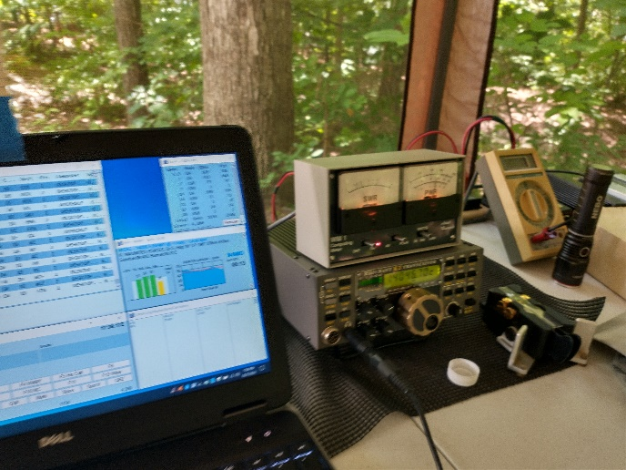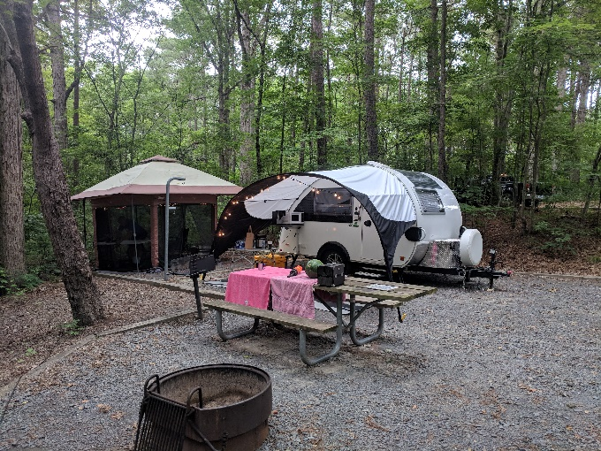
CW station by Marty W4MY – Swanky right!

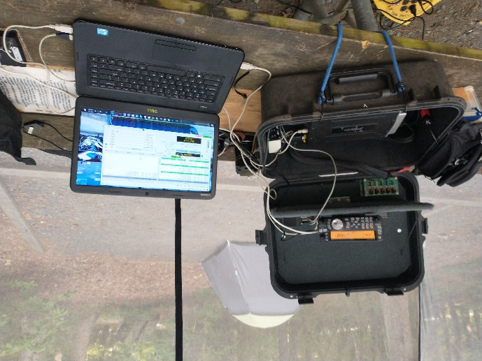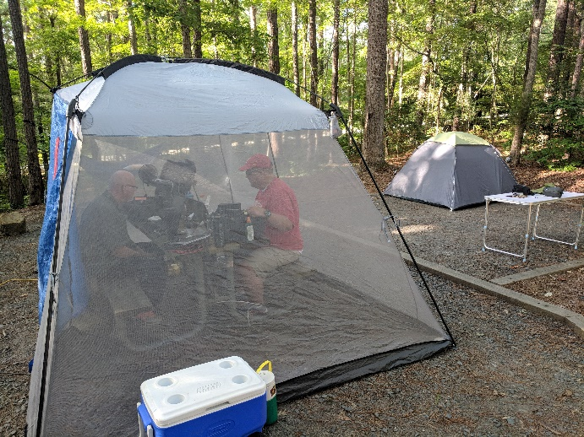
CW, SSB and DIG station by Dwayne N4MIO – N4MIO left and KF4VTT operating 6M on the right

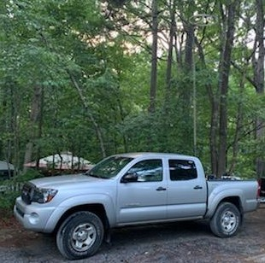
6M Halo and station provided by Doug KF4VTT

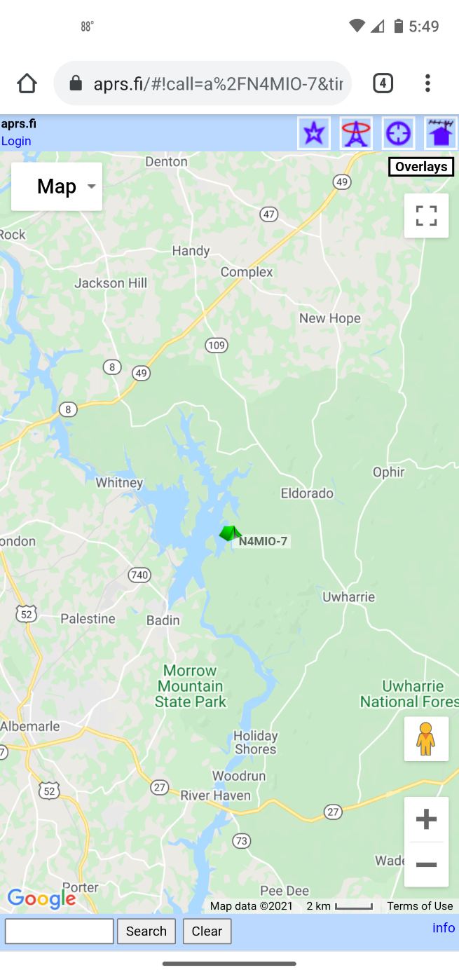
APRS position reporting by Dwayne N4MIO-7

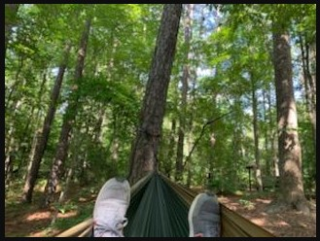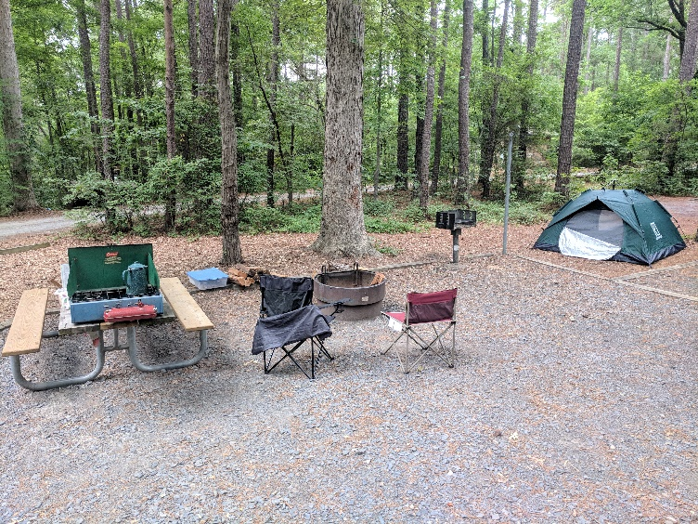
Doug KF4VTT Chillin! 3 campsites utilized – W4MGT sleep site and getaway site

