Cottonwood Heights ARC
Additional Bonus Point Verifications:
Youth Operator Log: 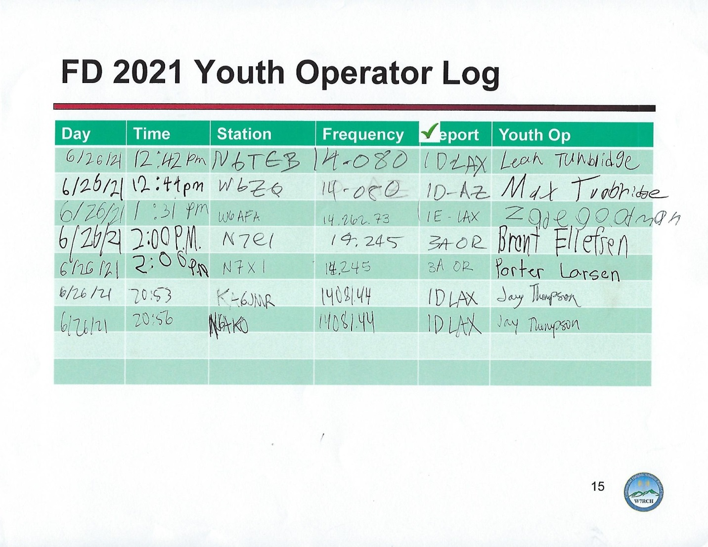

EOC Backup Generator Verification:
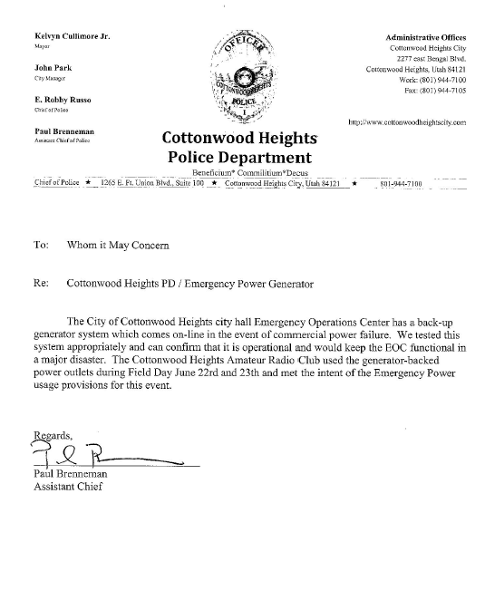

Educational Class: Anderson PowerPole installation Instruction by W7QL
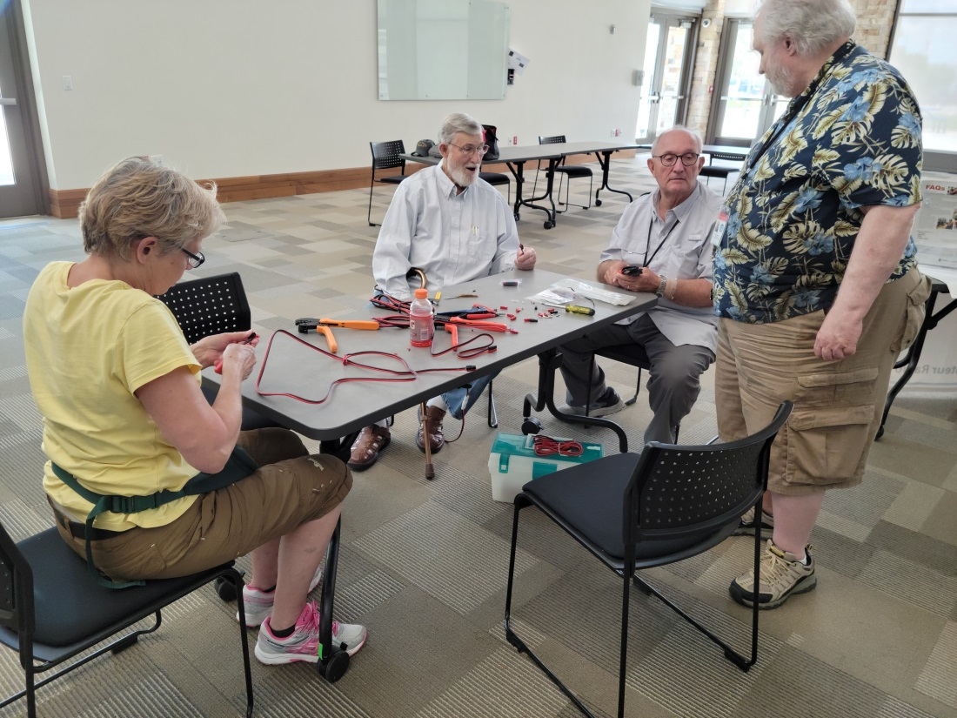

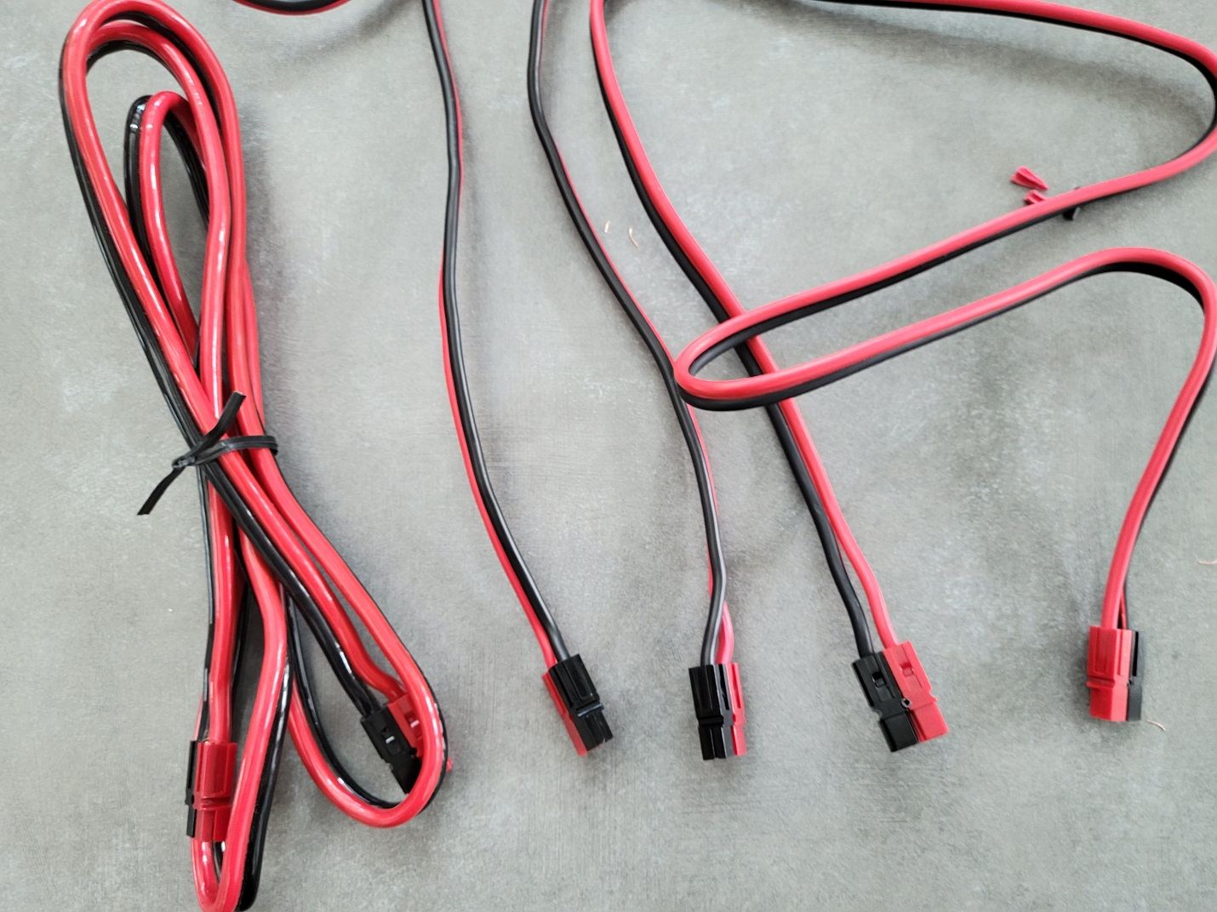

Elected Officials and Agency Officials
Elected:
City Council Members: Tali Bruce, Doug Peterson, Scott Bracken
City Officials:
City Manager Tim Tingey, Asst. Police Chief Paul Brenneman, Police Sergeant Ken Eatchel
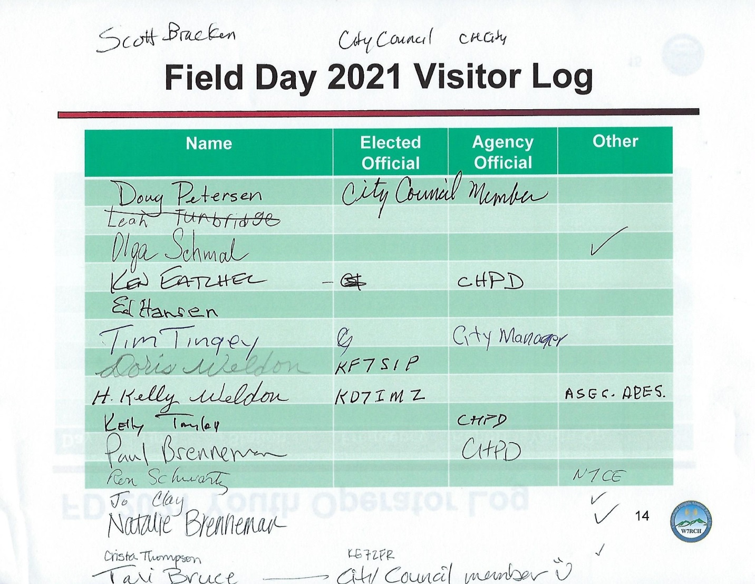

W7QL with Sergeant Eatchel at 2021 Field Day