WB0RMK 2025 Field Day

A Night to Remember
The SMARTS Radio Club organized Field Day Activities at the Lake Zumbro Group Camp Sites at Carver Park Reserve in Victoria, MN. We’ve operated from that location before, so we have experience with setting up antennas and making use of the existing shelter. We stay dry when it almost always rains.
Although we have a small number of members participating, our class is 3A, 4A or 5A, ensuring we have an operating position available for drop-in operators. Last year included a GOTA station for the first time. This year’s setup was 3A plus GOTA station.
Participants contributed an Icom (AH-4) and Yaesu (FC-40) remote tuners supporting most of the club member’s radios. This enabled a near vertical (FC-40) and an inverted-L (AH-4). We also set up 15M, 20M, and 40M tuned dipoles, with a 2M Yagi and a 6M ¼ wave vertical.
Part of the setup was cutting/tuning the 15M and 20M dipoles to length. This was part of the educational opportunity for newer hams; the wire used was cheap zip cord and it had unusual velocity factor properties requiring several iterations. We could also demonstrate the impact of near to the wire vegetation from our tree supports. Once centered in open space, the antennas were considered good-to-go for their specific band, with the resonant frequency known.
The dipoles and the remote tuned vertical were set up Friday night. Summer evenings in Minnesota, especially near a lake, generate lots of mosquitoes. Shelter is needed for a good night’s sleep. Bill, WF0B, tented outside, and Monte, AD0DB, tented inside the shelter. Thunderstorms rolled through in the wee hours, with no issue other than needing rubber boots in the morning.
Saturday morning allowed Bill, WA0GOG, to install the small generator and get AC wiring done to run the laptops. The logging server and network switch were all 12VDC powered, so we just made sure we had enough battery to support 24+ hour execution. We got the network up and running, with all three logging laptops reporting to the server. Over the last several years, participants have transitioned to newer laptops, with built-in Wi-Fi only. This led to the use of Wi-Fi only networking.
We planned to make digital contacts, requiring accurate timekeeping. With a GPS puck attached to the server, and the use of BKTTimeSync (Mauro, IZ23BKT), we were able to set the server time clock from the GPS and then act as a server for all the operating position laptops using BKTTimeSync. This setup simplified operations from past years where 5VDC hard wired GPSDO NTP server had to be placed on the network.
At 1800Z we were off and running. All operating positions were working. Given the antenna organization, we were able to run 20M phone and 20M digital without impacting each station – which was one of the objectives of the monoband antennas. We did need to provide bandpass filters for the operating positions associated with the remote tuners. Our lesson learned was to shift to monoband dipoles on HF for future Field Days and limit the use of a remote tuner for the GOTA station in the future.
During the event, we had ham and non-ham visitors. We provided information to those interested in becoming hams.
The cookout was held around 6PM local time, with Dakota Division Director Bill, AC0W visiting. Perfect timing for the group, since we tend to focus on the social and educational aspects of the Field Day event. As usual, there was enough food to feed a larger group, so no one went hungry. Thanks go to Rolf, KF0RFE for the brats and burgers; Jeff, KF0JW for the snacks; and Bill, KA0GOG for the fruit. Special thanks to Rolf and Jeff for their efforts in setting up and cooking the meal. We were able to snack well into Sunday!
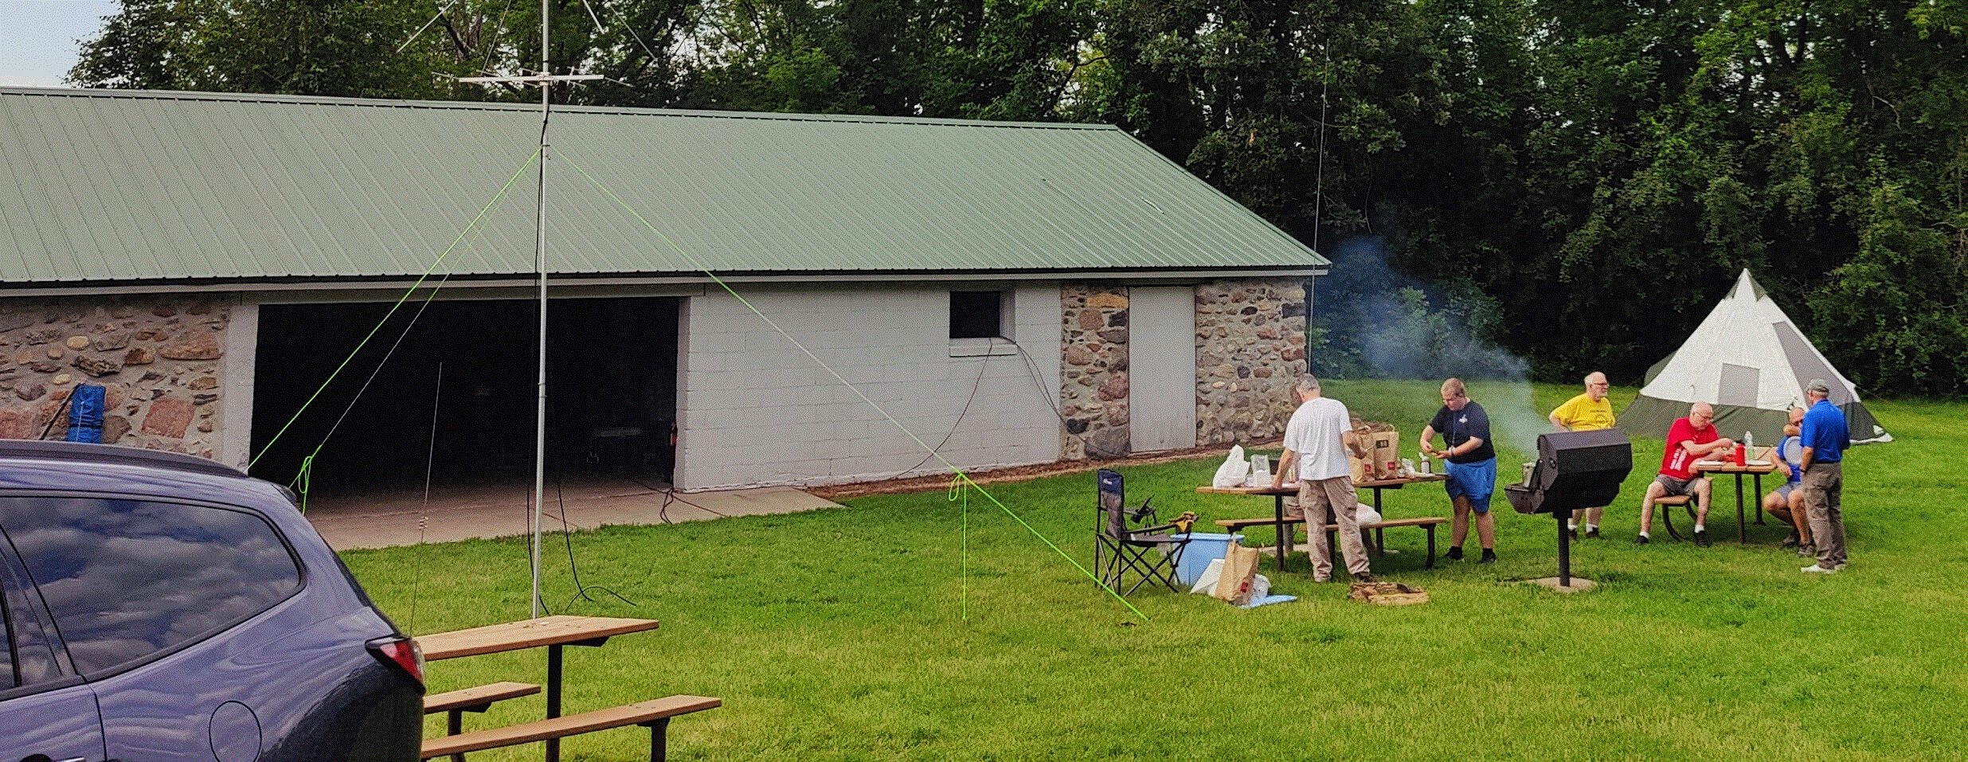
Figure 1 Shelter and Picnic (credit AD0DB)
After cleanup, operations started again. Monte, AD0DB assisted Mike, KD0DCZ getting the software setup for digital modes on Mike’s laptop. Jeff, KF0JW, then assisted Mike in operating WSJTX for making digital contacts.
As activities proceeded into the evening, eyes were on both the western horizon and Radar Scope. The Chanhassen NWS Radar is located about 6 miles away from our site – so they were involved in several warnings and watches for the evening. See https://www.weather.gov/mpx/June28SevereWeather for their perspective.
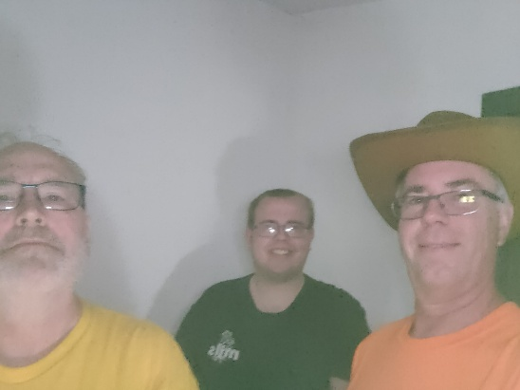
At about 11:00 PM we could hear thunder. We disconnected antennas, and shutdown for the evening. About 15 minutes later, Bill, WF0B, abandoned his outdoor tent and went home. It was clear, a very bad weather situation was coming.
Figure 2 Inside the "shelter" (credit AD0DB)
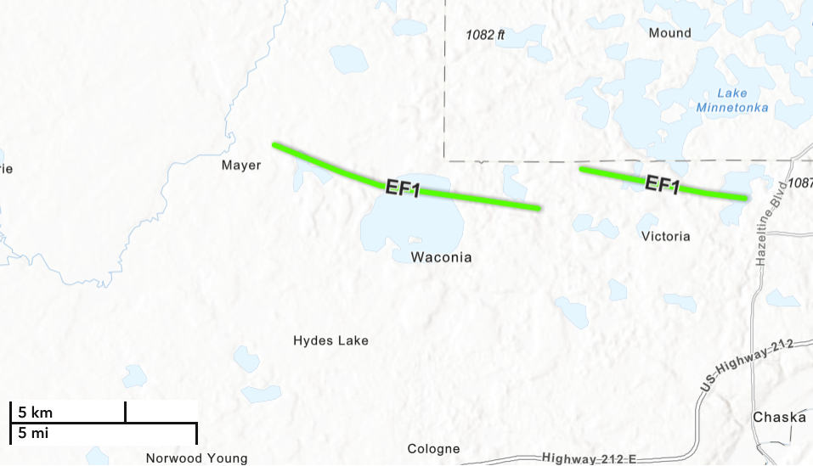
Then the sirens went off. As you can see from the picnic picture, the shelter has no glass in the window openings and has a huge opening. While helpful for ventilation, this is not a good location to shelter from a tornado. Monte, AD0DB, Jeff, KE0OOS and Jeff’s son left the shelter and went to the safest nearby shelter the concrete walled and roofed latrines.
Figure 3 https://www.weather.gov/mpx/June28SevereWeather
There were two tornados in the near vicinity. The western tornado is the Lake Waconia tornado, and the eastern tornado is the Lake Zumbra tornado.
The Lake Waconia tornado ended 3.06 miles from our site.
The Lake Zumbra tornado passed within ¼ mile of the camp site.
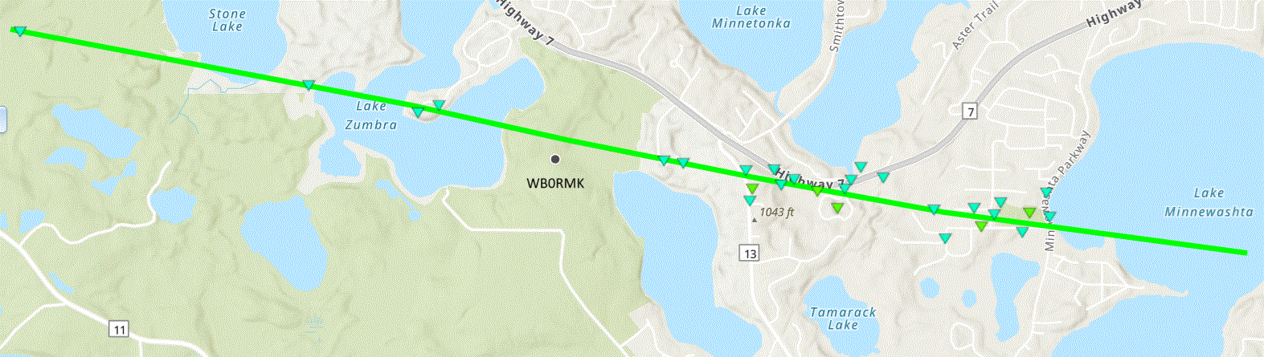
Figure 4 https://apps.dat.noaa.gov/StormDamage/DamageViewer/
No one was injured.
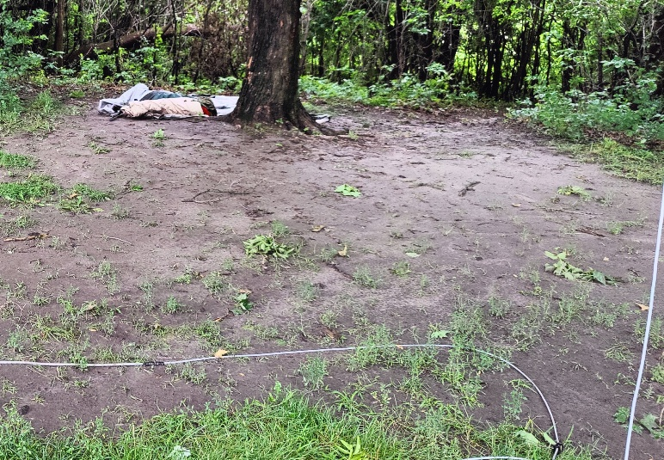
All radio equipment was safe. The outdoor tent and contents (minus WF0B) were blown into the trees. The 151 ft inverted-L on the remote tuner separated from the tuner, leaving antenna support and wire in the trees. The 15M and 40M dipoles failed when a tree limb came down on antenna supports. The break occurred at the feed point for the dipoles, not damaging the feed point balun wiring.
Figure 5 Tent found, 40M antenna leg in foreground (AD0DB credit)
Most of Sunday morning was spent cleaning up and getting damaged antennas down. Troy, K0LLT kept operating while the remaining focused on cleaning up.

Lessons Learned
After tearing down, cleaning up, and loading up, we generalized on lessons learned.
Our group tends to experiment, educate and socialize over attempts to get high scores. SMARTS hosts monthly POTA events, so members are used to setting up and operating portable. In the past, we’ve used multi-band antennas requiring tuning. Even with careful locating, we’ve needed to use passband filters. The monoband dipoles did NOT require the bandpass filters. This will become an important consideration for future events.
Since we like to plan to allow anyone to bring a radio and operate, we though a signup organized like this would help:
- Antenna Systems including antenna, antenna supports, coax, and common mode chokes
- Operating Position - Bring your own radio.
  - Will this include a logging laptop? If so, plan for time to add/update logging software.
  - Will this include a battery? Is the solar recharging for the battery?
  - Do you intend to operate digital modes? If you are not providing a logging laptop, then let us know the make/model so appropriate drivers can be installed.
- 12VDC Power sources. What is the AH capacity of the battery you’ll bring?
- 120VAC Power sources.
  - Are there battery and inverter sources available to power network computers?
  - Generator?
- Food
This approach would allow an individual to define an antenna, or a radio, or a power source or all three as an ala carte approach to contributing and experimenting.
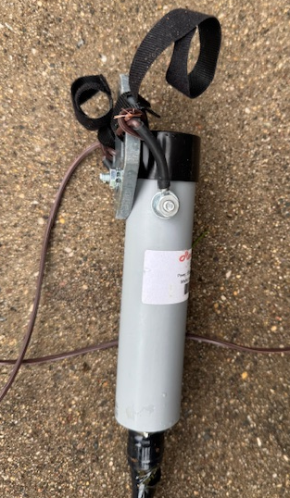
This was the first year where big branches fell on our antennas. While the long wire inverted-L came apart at the feed point, it was easy to get down – there was only wire and paracord to retrieve. For the dipoles, the break occurred at the center conductor. This made it difficult to get the tied off antenna end point through the tree branches. Living with the POTA ethos of nothing left behind, we needed the 24ft painter’s pole to assist lifting the end point over. We determined we needed a fusible link between the antenna end point and the support line. The intent of the fusible link is to break, leaving the antenna intact, and only the easily retrievable support in the tree.
Planning had site selection with an eye towards bad weather. Thunderstorms were in our collective experience at this site. However, we were NOT prepared for a tornado within a ¼ mile of us. Quick thinking led to shelter in the concrete latrines.
Figure 6 15M Feed point break

