Date of Report: June 30, 2026
Date of Event/Project: June 27, 2026
Prepared By: Perry Angiono – WB7NIL

1. Executive Summary

The 2026 Amateur Radio Field Day was a successful event focused on fostering a strong learning environment and mentoring new operators in high-frequency (HF) operations. Primary objectives included demonstrating diverse communication modes such as FT8, CW, and Winlink, as well as providing hands-on experience through a Get On The Air (GOTA) station for unlicensed guests. Despite challenging propagation conditions, the event effectively met its goals of operational readiness and member engagement.
Key operational highlights included the recording of 58 total contacts across voice, digital, and CW modes. Successes were noted in the mentorship program, where first-time Station Chiefs Mike and Daniel Avins demonstrated professional leadership in setting up and running their station. Furthermore, the implementation of a dedicated training tent with a projector facilitated effective FT8 demonstrations, and the successful execution of a foul-weather plan provided essential protection for both personnel and equipment, establishing a new standard for future operations.
Several logistical and technical challenges were identified, most notably the impact of poor propagation which largely restricted activity to the 20m band. Significant interference between stations occurred because antennas were placed too close to the operations center due to confusion regarding coax lengths. Additionally, the generator ran out of fuel because it was not actively monitored, and the club missed out on 100 bonus points because the W1AW CW bulletin was not copied due to a lack of available radios.
Moving forward, the club needs plans to prioritize year-round training and small-scale field operations, such as Parks on the Air (POTA), to maintain operator proficiency. Technical improvements will include standardizing GoKits with at least 100 feet of coax and implementing more rigorous generator fuel monitoring. Future efforts will also focus on enhanced community outreach to youth groups and site safety improvements, such as marking cables with colored flags and addressing environmental hazards at the site

2. Project/Event Objectives
We were onsite and operated as planned between 0830 and 2030 on Saturday, June 27, 2026.
Our objectives for this event are as follows:
- To have fun!
- To mentor new operators to take on leadership roles.
- To contact as many stations as possible on 40, 20, 15 and 10 meters.
- To encourage operators to get on the air and use CW, FT8 over voice to make as many contacts as they want.
- To send a minimum of 11 Winlink messages via VHF/UHF and route any messages received to the leadership.
- To learn to operate in abnormal situations in less-than-optimal conditions.
- To operate a GOTA station and to have non-hams and hams with no HF activity within a year operate the station and make contacts.
- To demonstrate and make operational an FT8 Station and have new operators use the system to make contacts.
- To demonstrate WSPR and propagation using PSK Reporter and VOCAP.
- To set up a communications area that would work in fair and foul weather conditions.

3. Actual Results
A factual, data-driven summary of the reality of the situation. Avoid excuses or explanations here—just list the facts.
It was a good time by all! Overall propagation this year was very bad. The only band that was very active and appeared to have propagation was 20m. This affected our 10m GOTA Station as well as FT8 and CW options. There was access to VOCAP prior to operations, but it was not considered or integrated into our operation. This is something to consider for next year – run VOCAP Prior to Field Day to get an idea about propagation.
The Foul Weather plan was executed, and although there was no rain as projected, our equipment and personnel were protected from the rain.
We had at least 1 non-licensed operator and several operators who haven’t been on HF in a while made contacts.
Station 1 was operated by new members, Mike Avins - KK7TAQ and his son Daniel - KK7TAR set up and ran station 1 like professionals. This was their first field day with the club and as Station Chiefs, and they did an outstanding job. Additionally, David MaCkichan - KK7WDO, stood up as the Assistant Safety Officer and helped by spouse, who was the designated Safety Officer ensuring our operation was safe. David did a great job and my spouse appreciated that he was backing her up.
The total number of contacts we made on Saturday was 58. This is a combined score of CW, FT8 and voice.
We had 3 operators get on FT8 and help with racking up our digital points.
We processed 13 Winlink messages via VHF/UHF.

4. Analysis & Evaluation
This is the core of the AAR. The team analyzes the gaps between the plan and the reality, examining both successes and failures.

What went well
We had a new station Chief for Station 1, Mike and Daniel, who did a great job setting up and operating their station.
The Honey bucket was a big hit.
The event was fun and successful in that we had new people there who have never been on the HF before were able to make contacts for Field Day.
We made the following contacts:
Voice: 39
CW: 3
FT8: 16
WINLINK: 13
Station Chiefs were much more familiar with their responsibilities, equipment and the ARRL Rules. From 2025 FD, lessons learned, we printed off the documents for their stations as well as guides for voice and CW exchange. The Station 1 OPS Chiefs needed little to no assistance in getting their station up and running due to their experience as operators. I validated operations and we were good to go.
N7VWD Sent 11 Winlink messages using WA7FW. One was to the ARRL Section Manager which we received a response.
The demonstration and training of FT8 was well received. Conducted training on FT8, made 2 contacts, and then handed over to new operators.
We set up a Training Tent with Projector next to Station 3 as discussed in the plan. This worked very well allowing folks to see the demo as well as what the operator was doing on FT8.
GOTA Station was operational and had 2 licensed and 1 unlicensed guest operators.
The MESH Network was up and operational. Learned that on the FT8 Station, if Gridtracker is running, then we could not upload data to the networked N3FJP log. Ran the rest of FT8 without Gridtracker.
From last year, we standardized the naming convention for each station in N3FJP Logger. This allowed us to ID which station were on what bands.
We did a better job tracking visitors and club members in our sign in logs. Liz Angiono was assigned to watch for visitors and ensure they logged in. There were a couple of folks that got past the visitor’s tent, but there was an improvement over last year.
Planning was done by Zoom, and it was well received and productive.
FAIR AND FOUL WEATHER PLAN: Although a foul-weather plan was not initially considered, it was developed quickly and will become our standard setup in future operations because we operate in rainy Washington.
STATION BINDERS: Each station was provided with a binder that contained the Band Plan, basic examples of the exchange used on FD, the RAC codes, a notepad and pen to help them operate their station. Not sure how effective they were, but the information was available to all Station Chiefs.
All tents had at least 1 side setup for as a windbreak and rain protection. However, the Visitor’s Tent was not visually accessible by any of the other stations due to the cover blocking the inner circle of the operations area. Consider a different angle or location for the Visitor’s tent.
Teamwork was very strong. Every able person helped set up the antenna masts and this was done without much help from more experienced people. The Masts were checked to by mentors to ensure they were done properly.
Station 2, the 20m station, was set up by our deadline of 1100 for when the Mayor of Federal Way was expected to arrive.

What Went Wrong
Propagation was bad this year. The only band that was very active and appeared to have propagation was 20m. VOCAP was not performed so I don’t know what the predictions were during FD.
Like last year, the Bandpass filters worked well. However, when operating on the same band (digital/CW/Phone), which did occur due to 20m being the hottest band. CW/digital was attempted on 15m, but noise and propagation was terrible. So went to the low end of 20m and ran 20W. This still caused interference at the 20m station. Notch filters did not help. Had to suspend FT8 ops to allow for voice to resume.
Configurations: With 4 stations, we need to ensure we have enough separation between the antennas. We used 2 AC Delta 80-10 Fan dipoles in an inverted V configuration, a 20m Dipole, and a POTA Performer (20-6m). All antennas tuned up and worked within their design parameters.
The generator ran out of gas as it was not being monitored.

5. Key Takeaways & Lessons Learned
There was confusion regarding which coax to use as our plan was for a 50ft run out to the base of the mast and 50 ft up, but we ended up running 50ft out to the antenna causing our antennas to be closer to our Operations Center. Each HF GoKit should have 2 @ 50Ft runs of coax and checked before field day. This way we can run out to at least 60 Ft and up 40 to an antenna. We need to verify that each HF GoKit has at least 100Ft of coax for HF.
Station Captains need to verify that they have 100Ft of Coax when setting up their station, and if not, let the OPS Chief/Logistics Chief know.
We invited the local scouting groups to Field Day, but unfortunately, they did not visit us. We need to do a better job communicating Field Day to youth groups and then follow up with them.
Need to ensure that documentation makes it clear where each goKit goes. This year we had some kits split up, but they should stayed together. I.E., GoKit 1 goes to Station one, including the masts, tent, table and chairs.
The FWARC Field Day Operations Manual needs to include all of the ARRL Field Day rules so we can look up something if needed. The guide was initially intended to be a guide to operating and set up and not the Field Day Admonition Manual. Next year the manual should include the ARRL Field Day guide for quick reference in the field.
Hydration and Meals during operations: It was observed by our Safety Officer that folks had water but she saw no one taking breaks to eat. Need to make this a point during the Initial Briefing.
Need to ensure that participants bring a lunch or something to snack on through the operation as well as making sure folks stay hydrated.
Water should be available at the visitor’s Tent for easy access to operators.
TENTS: We had one tent get airborne because it was not staked down. Need to inspect that all tents are secured.
Ken – AG7QU had a much heavier mallet (personal) in his kit that made it easier to drive in the stakes. We should look at upgrading the mallets in the GoKits.
N3FJP LOG: Since the GOTA site is not connected to the network, and logging is done locally on N3FJP, we need to ensure we get the log off the computer before we shut down. Maybe Sneaker Net to the server. This year, AF7O got the logs off of the GOTA computer.

6. Action Plan & Next Steps
Although we had a good event, there are areas that we can improve on. Here are some observations and things that came up throughout the day and after:
- Training, Training, Training!!!! We need to continue training for field day throughout the year. As we gain experience in conducting Field Day in an ICS environment, we always find areas that we need to learn before field day so we are better next time.
- Need to have more practice operating radios in the field. Considering doing small field operations in the local parks in FW, or even POTA’s at the Dash Point State Park.
- Prior to Field Day, we need to make sure all required equipment is checked out and operational prior to the event.
- We need to ensure that our equipment arrives on time at the Event Site per the ICS 201.
- Modify the Field Manual and include it in the briefing, to make sure that the GoKits and other equipment are placed at the correct location. Need to make the instructions clearer for Station Chiefs.
- Modify the Field Manual to make sure during setup and teardown, that we are not grabbing equipment, items, etc, from kits and just putting them in the wrong GoKit.
- Address how Club members who do FD from home can get their points aggregated with our Field Day. This would increase our performance points. This is found under rule 7.0 Aggregate Club Score.
- Address and explore the rules more closely for using batteries, QRP and generator power and see if there are any opportunities for more points.
- ICS FORMS: Need training on how to use them as well as how to fill them out properly. Specifically, the IC-214 and IC-213. Then how to use the other forms that were used in Field Day.
- WINLINLK: We need to ensure that all the information that is required is include in the message. This year, we left off how many participants in our outgoing WINLINK messages. In the Spirit of ICS, does the EC/IC need to approve all outgoing messages, or do we need a delegation statement somewhere that gives the authority to whomever is sending out formal message traffic. The number of people at the event is usually required in the message. That information is available from the sign-in sheet.
- WINLINK: Once Winlink is operational, keep it online until operations end. This way we are available to capture any incoming messages from other clubs during our operation. Also check WINLINK by 0000 UTC on the following day for any messages that may have been received.
- WINLINK: For submission to the ARRL, the WINLINK operator needs to print all messages sent and received into PDF from the computer where it originated to show all the header information.
  - Copies of messages were sent to me – WB7NIL – but it became unclear if processed via RF. Cleaning up messages for submission is time consuming and would make more sense to come from the WINLINK Computer.
  - The pdf needs to be printed from the original computer running RMS so the ICS213 format is clear and saved. Name convention Starts with “TO” or “FM” and then Call/name / title/posn / and ending with IC213.pdf. One message per callsign to ensure clear documentation.
- INVITES/DIGNITARIES: Besides the Mayor and FW Leadership, we need to send invites to the County Sheriff, Chief of Police, Battalion Fire Chief, Local Fire Station Chief, and/or Senior Fire Department Leadership etc.
  - No scouts showed up, but we need to continue to formally invite the local scouting communities.
  - Local School’s Robotics/electronic clubs/classes.
- SAFETY Concerns:
  - When we make our reservations for next year, include to have the two trees on either side of the path (BBQ area) to be trimmed up to 7 feet so no one gets poked in the eye with branches. Additionally, we need the Parks Department drop off 5 safety cones so that we can block off the dropoff next to the path and mark the low spot near the path.
  - MEDICAL: Identify any staff who is certified in CPR and First Aid. Do we have access to an AED and persons trained to use it? Make sure all staff know that the Visitor Tent is also the 1st Aid Station. Post a sign labeled “First Aid Station” or something like that. Make sure we have First Aid supplies (we did have basic 1st Aid stuff there this year).
  - Modify the Comms plan to include Cellphones as our primary means for contacting EMS. The Security Officer is the main POC.
  - Purchase Colored flags to stick in the ground around cables.
- 7.3.9. W1AW Bulletin: We missed this opportunity as the CW Bulletin was not copied. This will provide 100 bonus points if copied. No one copied the W1AW CW Broadcast messages because band selection was limited due to propagation and there were no radios available for copying the broadcast messages. Maybe look at having a separate location and receive/antenna for the purpose of copying the broadcast messages from the ARRL and making this aware to operators that it is available. There could be an issue with QRM from our other stations.
- Include the additional FT8 Frequencies listed in the ARRL FD Packet. If we do FT8 again, we need to ensure they are used as 20m was really packed! Add these to the Station Binder for FT8.
- Include FT4 as part of our digital station. May have been able to make more connections there. Duty Cycle is longer, so more stress on the equipment.
- COMPUTER NETWORK: Consider having a network diagram and ensure that all computers are connected to the MESH Network. We did have Starlink available at the site (provided by WB6CFA), but no plan to use it.
- PSK REPORTER: Need to figure out how to allow Gridtracker to work with the N3FJP Server via the MESH Network. I was able to maintain connection to the MESH Network while also having a wifi connection to Starlink. However, when I engaged Gridtracker for tracking and logging FT8, it would not allow connection to the N3FJP Server, so Gridtracker had to be shutdown. This had no impact on our FT8 operation, it was just a tool we could not use that simplified the process.
- LOGISTICS: Identify (usually the Logistics Officer) someone to monitor the operation of the Generator. Make sure that it does not run out of fuel.
- Ensure we have a second Generator on station and full fuel can on station.
- Ensure we have a VHF/UHF radio monitoring our call-in frequency. This should be done at the Visitor’s Tent.
- PROJECT: A few folks talked about maybe building an HF Yagi that we can use for FD, or maybe a DYI Hex Beam for use by the club.
- COAX: Ensure each HF GoKit has a minimum of 100 Ft of RG213, or RG8x. There is about a 2db loss on 10m @ 100ft with RG8x compared to .7 db on 10m @ 100Ft. With RG8x, the resulting signal on the other end is 1/3 of an S unit in that 6db loss equates to 1 full S Unit. RG8x is less expensive and easier to work with and store.

WA7FW Summary Sheet

Total Contacts by Band and Mode:

Band CW Power Dig Power Phone Power Total %
---- -- ----- ----- ----- ----- ----- ----- ---
40 3 0 21 24 41
20 0 14 18 32 55
15 0 2 0 2 3
-- ----- ----- ----- ----- ----- ----- ---
Total 3 16 39 58 100

WA7DR Summary Sheet

Total Contacts by Band and Mode:

Band CW Power Dig Power Phone Power Total %
---- -- ----- ----- ----- ----- ----- ----- ---
10 0 0 4 4 100
-- ----- ----- ----- ----- ----- ----- ---
Total 0 0 4 4 100

Dupe Sheet WA7FW
Call Used: WA7FW Class: 3A ARRL Section: WWA

Dupe Sheet

40 CW
KQ7I
NF7N
W7WHR

40 CW Total Contacts = 3

40 PH
AE5Q
AG6AU
K7FDF
K7LED
K7LYY
KA7AKU
KC7H
KE7F
KG7KQT
KK7ELZ
KX7ID
N6BLU
N7FRO
NC7G
VE7CRC
W7ASY
W7AW
W7DW
W7GRA
W7W
WQ6L

40 PH Total Contacts = 21

20 DIG
AB4OB
K7RE
K7YMG
KD6SPN
KF6JBN
KH2SR
KN4UDS
KZ7K
N5BL
N6GRM
NK3L
VE6FT
W8TCS
WC7F

20 DIG Total Contacts = 14

20 PH
AC7YT
AL7LE
K7IDX/7
K7ST
K9SS
N5GK
N6MI
N7RB
NM5HR
VE6FI
VE7OGO
W0ALX
W0DZ
W6AFA
W7DK
W8FY
W9W
WA0FYA

20 PH Total Contacts = 18

15 DIG
W4TA
W7S

15 DIG Total Contacts = 2

Dupe Sheet WA7DR

Dupe Sheet
Call Used: WA7DR Class: 3A ARRL Section: WWA
10 PH
K8BF
VE5MA
WA3COM
WA7KCK

10 PH Total Contacts = 4

WA7FW's Contest Summary Report for ARRL-FD
Created by N3FJP's ARRL Field Day Contest Log
Version 6.6.10 www.n3fjp.com

Total Contacts = 58
Total Points = 77

Operating Period: 2026/06/27 18:19 - 2026/06/27 21:54

Total op time (breaks > 30 min deducted): 1:59:56
Total op time (breaks > 60 min deducted): 3:35:02

Avg Qs/Hr (breaks > 30 min deducted): 29.0

Total Contacts by Band and Mode:

Band CW Phone Dig Total %
---- -- ----- --- ----- ---
40 3 21 0 24 41
20 0 18 14 32 55
15 0 0 2 2 3
-- ----- --- ----- ---
Total 3 39 16 58 100

Total QSOs Running = 10, Minutes = 47, Rate = 12.8
Total QSOs Search and Pounce = 48

Run Activity Summary

Frequency QSOs Start Stop Minutes Qs/Hr
--------- ---- ----------- ----------- ------- ------
14.076 3 06/27 22:15 06/27 22:41 26 6.9
14.076 3 06/27 22:44 06/27 22:51 7 25.8
21.076 2 06/27 20:38 06/27 20:51 13 9.2
14.077 2 06/27 21:49 06/27 21:49 1 120.0

Total Contacts by Section:

Section Total %
------- ----- ---
WWA 8 14
OR 6 10
ID 4 7
MT 4 7
NM 3 5
SCV 3 5
AB 2 3
AZ 2 3
BC 2 3
EWA 2 3
IL 2 3
LAX 2 3
NFL 2 3
SDG 2 3
UT 2 3
AK 1 2
AR 1 2
CO 1 2
EB 1 2
MN 1 2
MO 1 2
NV 1 2
OH 1 2
SB 1 2
SJV 1 2
SV 1 2
WCF 1 2

Total = 27

Total Contacts by State \ Prov:

State Total %
----- ----- ---
CA 11 19
WA 10 17
OR 6 10
ID 4 7
MT 4 7
FL 3 5
NM 3 5
AB 2 3
AZ 2 3
BC 2 3
IL 2 3
UT 2 3
AK 1 2
AR 1 2
CO 1 2
MN 1 2
MO 1 2
NV 1 2
OH 1 2

Total = 19

Total Contacts by Country:

Country Total %
------- ----- ---
USA 53 91
Canada 4 7
Alaska 1 2

Total = 3

Total DX Miles (QSOs in USA not counted) = 10,577
Average miles per DX QSO = 2,115

Average bearing to the entities worked in each continent.
QSOs in USA not counted.

NA = 119

Total Contacts by CQ Zone:

CQ Zone Total %
------- ----- ---
03 40 69
04 14 24
05 3 5
01 1 2

Total = 4

Total Contacts by Grid:

Grid Total %
--------- ----- ---
56 97
DN40 1 2
EL87 1 2

Total = 2

Total Contacts by Initials:

Initials Total %
-------- ----- ---
46 79
PRA 12 21

Total = 1

Total Contacts by Operator:

Operator Total %
-------- ----- ---
46 79
WB7NIL 12 21

Total = 1

Total Contacts by Station:

Station Total %
------- ----- ---
GoKit01 24 41
Station02 18 31
FT8 12 21
4 7

Total = 3

Total Contacts by Computer:

Computer Total %
------- ----- ---
GoKit01 24 41
FWARC-GoKit03 18 31
i5Notebook 12 21
4 7

WA7DR's Contest Summary Report for ARRL-FD
Created by N3FJP's ARRL Field Day Contest Log
Version 6.6.10 www.n3fjp.com

Total Contacts = 4
Total Points = 4

Operating Period: 2026/06/27 19:21 - 2026/06/28 00:46

Total op time (breaks > 30 min deducted): 0:15:10
Total op time (breaks > 60 min deducted): 0:15:10

Avg Qs/Hr (breaks > 30 min deducted): 15.8

Total Contacts by Band and Mode:

Band CW Phone Dig Total %
---- -- ----- --- ----- ---
10 0 4 0 4 100
-- ----- --- ----- ---
Total 0 4 0 4 100

Total QSOs Running = 0
Total QSOs Search and Pounce = 4

Total Contacts by Section:

Section Total %
------- ----- ---
OH 1 25
SK 1 25
WPA 1 25
WWA 1 25

Total = 4

Total Contacts by State \ Prov:

State Total %
----- ----- ---
OH 1 25
PA 1 25
SK 1 25
WA 1 25

Total = 4

Total Contacts by Country:

Country Total %
------- ----- ---
USA 3 75
Canada 1 25

Total = 2

Total DX Miles (QSOs in USA not counted) = 2,290
Average miles per DX QSO = 2,290

Average bearing to the entities worked in each continent.
QSOs in USA not counted.

NA = 74

Total Contacts by CQ Zone:

CQ Zone Total %
------- ----- ---
04 2 50
03 1 25
05 1 25

Total = 3

Total Contacts by Unique Call = 4

WA7FW Contact MAP

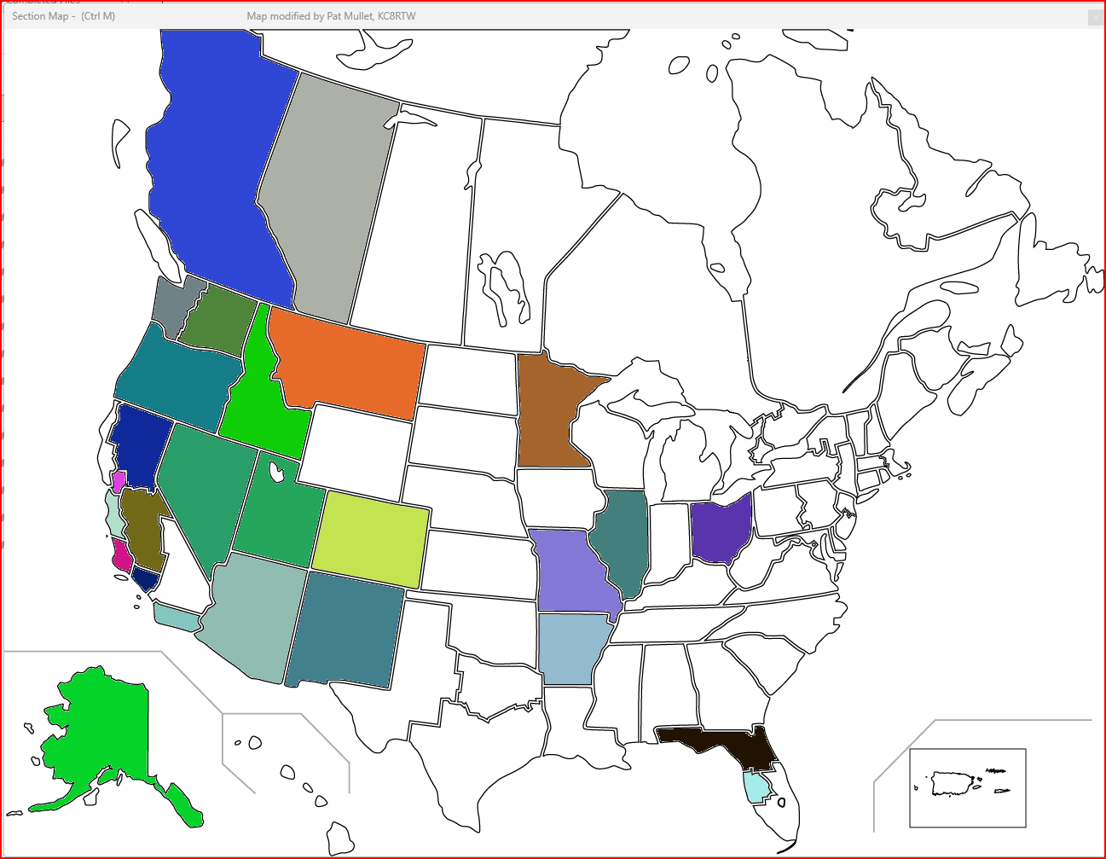

WA7DR Contact Map

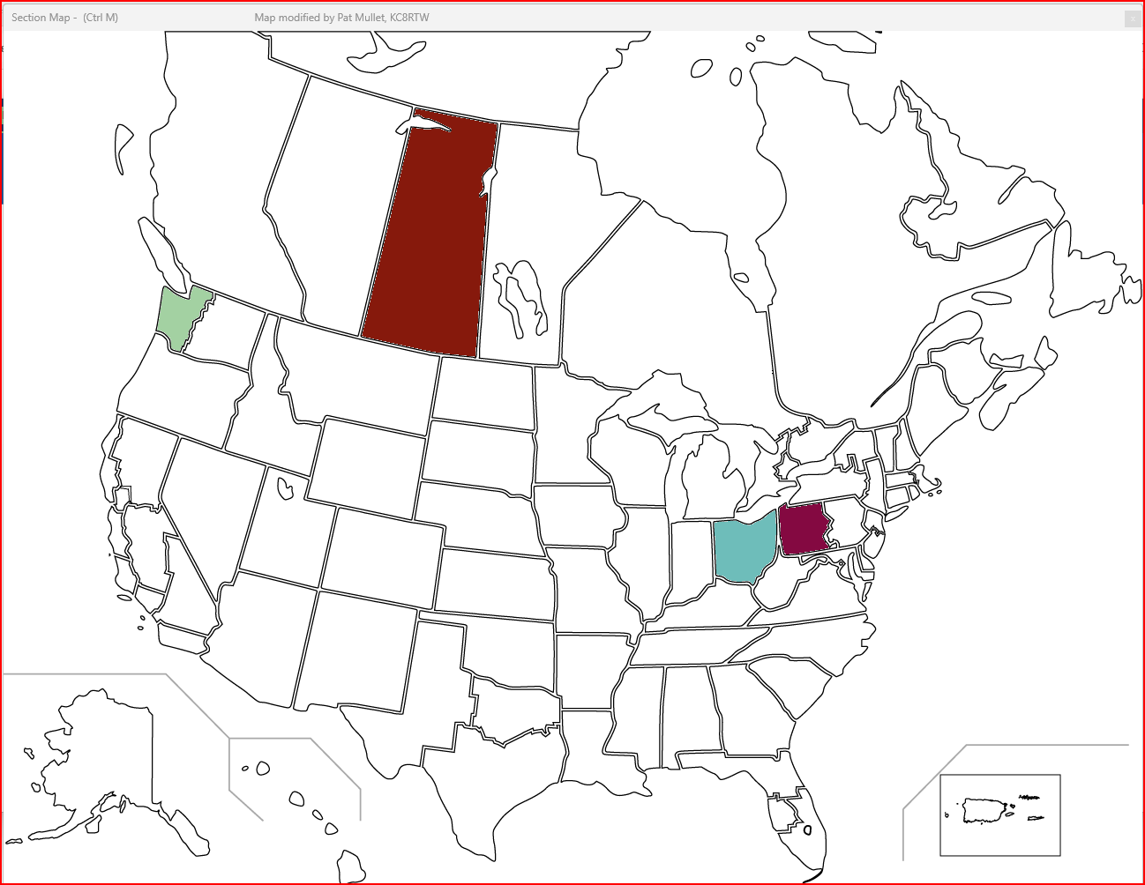

WINLINK:

No. | Name | Call | Title | WL Address | Email | Msg # | Comments
 | Bob Purdow | AD7LJ | ARRL WWA Section Manager | ad7lj | AD7LJ@arrl.net | 1 | SM Msg
1 | Jim Monson | K7JGM | King Co ARES Dist EC | k7jgm | K7JGM@ARRL.net
2 | Kirk Bellar | N7UK | King Co Asst ARES Dist EC | n7uk | n7uk@arrl.net
3 | Monte Simpson | W7FF | WA State RACES Officer | w7ff | w7ff@arrl.net
4 | Scott Dakers | W7SGD | WA State EOC Radio Room Mgr | NNA0WA
5 | Jasson Shirron | KE7EEL | King Co EOC Program Manager | ke7eel; k7ecc | jason.shirron@kingcounty.gov
6 | Grant Miller | W7GTM | Pierce Co ARES | w7gtm | ADEC2@piercecountyares.net
7 | Mark Yordy | W7BBO | Pierce Co ARES | w7bbo | ADEC@piercecountyares.net
8 | Stan Nelson | W7DKK | Pierce Co ARES | w7dkk | k7dkk1@gmail.com
9 | Kevin Pelley |  | Greater FW Emergency Manager |  | kevin.pelley@federalwaywa.gov
10 | Shannon Markham |  | Pierce County Emergency Management |  | shannon.markham@piercecountyWA.gov

A total of 11 Winlink Messages were sent as indicated above. We also received 4 emails replies back within the Field Day operating period.

Although we show in our EAP that we are operating Field Day on 1 of the 2 days, there is no where in the ARRL submission form that says you have to specify your operating hours. Therefore, as I see it, if we get traffic through the next day, then that traffic counts.

PSK Report on WA7FW FT8 Operations

