Bonus point summary 7/26/2025 Field Day 2025
7.3.1. 100% Emergency Power: 200 pts
All stations ran off battery power at our Field Day location. With a 100 Amp/hr battery for backup power through the night and solar power charging.

7.3.2. Media Publicity: 100 bonus points may be earned for obtaining publicity from the
local media. A copy of the actual media publicity received (newspaper article, etc.) must be
submitted to claim the points. Any combination of bona fide media hits would qualify for
the bonus points. For example, details of your upcoming or ongoing Field Day activity, or
your Field Day results, as posted on a news media site (which could include the media site’s
Facebook, Twitter, or Instagram) would meet the bonus criteria.
GHRC sent media publicity to the local newspapers, invited many organizations via email (Scouting America, STEM clubs, 4H, Trail Life, American Heritage, Red Cross, Mayors, Sheriffs, Search and Rescue, Back country Hikers and Horsemen, 4x4 clubs, etc.), put the event in every event calendar in the county, and made a radio interview to be aired on several radio stations in the area. Included is the YouTube radio clip that was aired at the dates and times listed below.
https://www.youtube.com/watch?v=1f_i3CRcXdA
Radio clip and times it was aired:
Here follow the radio promotions that we know are scheduled:
DAYS (& TIMES WHEN KNOWN) & FREQUENCIES & STATION NAMES
Tuesday June 24 (7:30 a.m. and 9:30 a.m.) 95.9 KGVM
Wednesday June 25 [none known]
Thursday June 26 104.7 and 105.7 The Eagle, 106.9 Sky Country
Friday June 27 (8:30 a.m.) 95.9 KGVM and unknown times of Eagle stations
Saturday June 28 [none known]
Sunday June 29 unknown times of Eagle stations and Sky Country station
7.3.3. Public Location: 100 bonus points for physically locating the Field Day operation in a
public place (i.e. shopping center, park, school campus, etc) and actively welcoming the
public. Person(s) shall be available to greet the public and be identified by some sort of
name badge. The intent is for amateur radio to not only be on display to the public, but to
also engage any visitors showing up at your location.
All operating positions were located adjacent to the town – Gallatin Gateway. A PR table was set up; passers-bye and visitors were met by club reps and info shared about ham radio, emergency operations, etc. Pamphlets were given to them. Some of our active club members had a name tag with their call sign and a smile, to greet the public.
7.3.4. Public Information Table: 100 bonus points for a Public Information Table at the
Field Day site. The purpose is to make appropriate handouts and information available to
the visiting public at the site.
A PR table was set up; passers-bye and visitors were met by club reps and info
shared about ham radio, emergency operations, etc. Pamphlets were given to them.
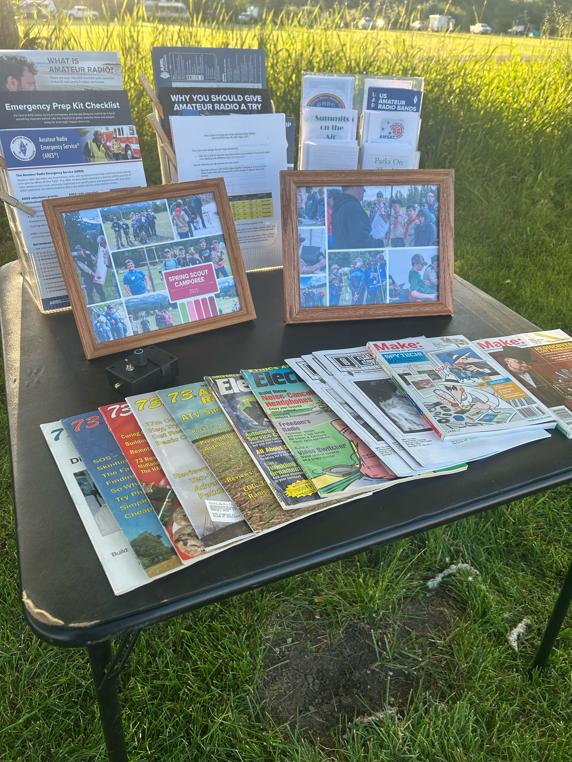

7.3.5. Message Origination to Section Manager: 100 bonus points for origination of a formal
message to the ARRL Section Manager or Section Emergency Coordinator by your group
from its site. You should include the club name, number of participants, Field Day location,
and number of ARES operators involved with your station. The message must be
transmitted during the Field Day period and a copy of it must be included in your
submission in either standard NTS or ICS-213 format. The message must leave or enter the
Field Day operation via amateur radio RF.
*Message from KE7NLU to WA1TYB (SEC):
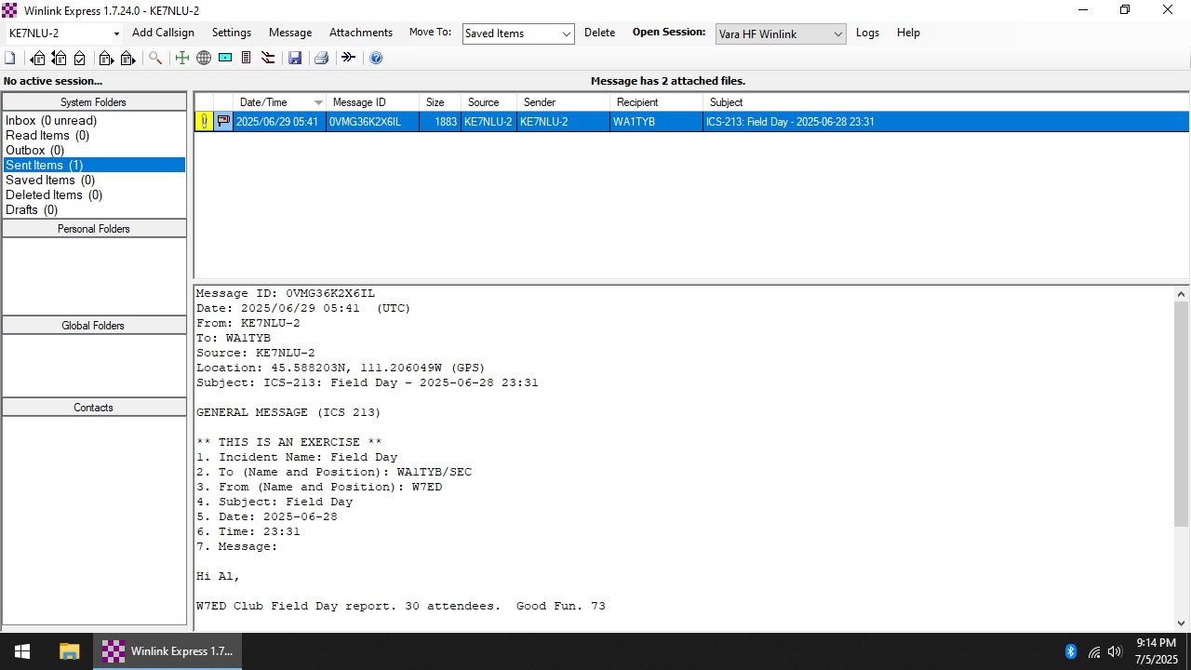

7.3.6. Message Handling: 10 points for each formal message originated, relayed or received
and delivered during the Field Day period, up to a maximum of 100 points (ten messages).
Copies of each message must be included with the Field Day report. Messages claimed
under this bonus must be in either standard NTS or ICS-213 format. All messages claimed
for bonus points must leave or enter the Field Day operation via amateur radio RF.
We had no messages handled on-site except the SEC message.
7.3.7. Satellite QSO: 100 bonus points for successfully completing at least one QSO via an
amateur radio satellite during the Field Day period.
We did not have a successful Satellite QSO, but it was not for lack of effort.
7.3.8. Alternate Power: 100 bonus points for Field Day groups making a minimum of five
QSOs without using power from commercial mains or petroleum driven generator. This
means an "alternate" energy source of power, such as solar, wind, methane or water. This
includes batteries charged by natural means (not dry cells). The natural power transmitter
counts as an additional transmitter. If you do not wish to increase your operating category,
you should take one of your other transmitters off the air while the natural power
transmitter is in operation. A separate list of natural power QSOs should be submitted with
your entry.
All of our stations ran continuously on battery backup power. This was a large-capacity battery/inverter arrangement. This battery arrangement was previously charged using solar panel power. Portable stations/Gobox stations used battery power and were charged utilizing solar charging, before and during Field Day.
7.3.9. W1AW Bulletin: 100 bonus points for copying the special Field Day bulletin
transmitted by W1AW (or K6KPH) during its operating schedule during the Field Day
weekend. An accurate copy of the message is required to be included in your Field Day
submission.
We had no stations able to copy the W1AW message.
7.3.10. Educational activity bonus: One (1) 100-point bonus may be claimed if your Field
Day operation includes a specific educational-related activity. The activity can be diverse
and must be related to amateur radio. It must be some type of formal activity.
We had a scout family come to our Field Day location. After making contacts on the GOTA station, some of our club members educated the family and the group on how to find a hidden fox transmitter, the different frequencies utilized in ARDF, and how to utilize a radio to find a hidden transmitter. We used the same directional antenna set-up used with the Spring Camporee fox hunt with the Mountain Valley District of Scouting America. After the short tutorial, they were off hunting 3 transmitters hidden around our Field Day site. By the smiles witnessed, they all had a great time enjoying the adventure with family.
7.3.11. Site Visitation by an elected governmental official: One (1) 100-point bonus may be
claimed if your Field Day site is visited by an elected government official as the result of an
invitation issued by your group.
We did not have a governmental official visit our site.
7.3.12. Site Visitation by a representative of an agency: One (1) 100-point bonus may be claimed if your Field Day site is visited by a representative of an agency served by ARES in your local community (American Red Cross) as the result of an invitation issued by your group.
We did not have a representative of any agency visit our site. But we did have a visitor swing by who saw the announcement of our Field Day location from the American Red Cross.
7.3.13. GOTA Bonus: Class A and F stations operating a GOTA station may earn the
following bonus points:
7.3.13.1. Any successfully completed contacts made by an operator
at the GOTA station are worth five (5) bonus points, regardless of
mode used. There is no limit to the number of contacts a single
GOTA operator can make. The GOTA station bonus points are not
multiplied by the power multiplier (this is a clarification of the
rules published in 2023.) 50 Bonus Points.
We made 10 successful GOTA contacts. Callsign used was KE7NLU. Included is the GOTA Station QSO’s:
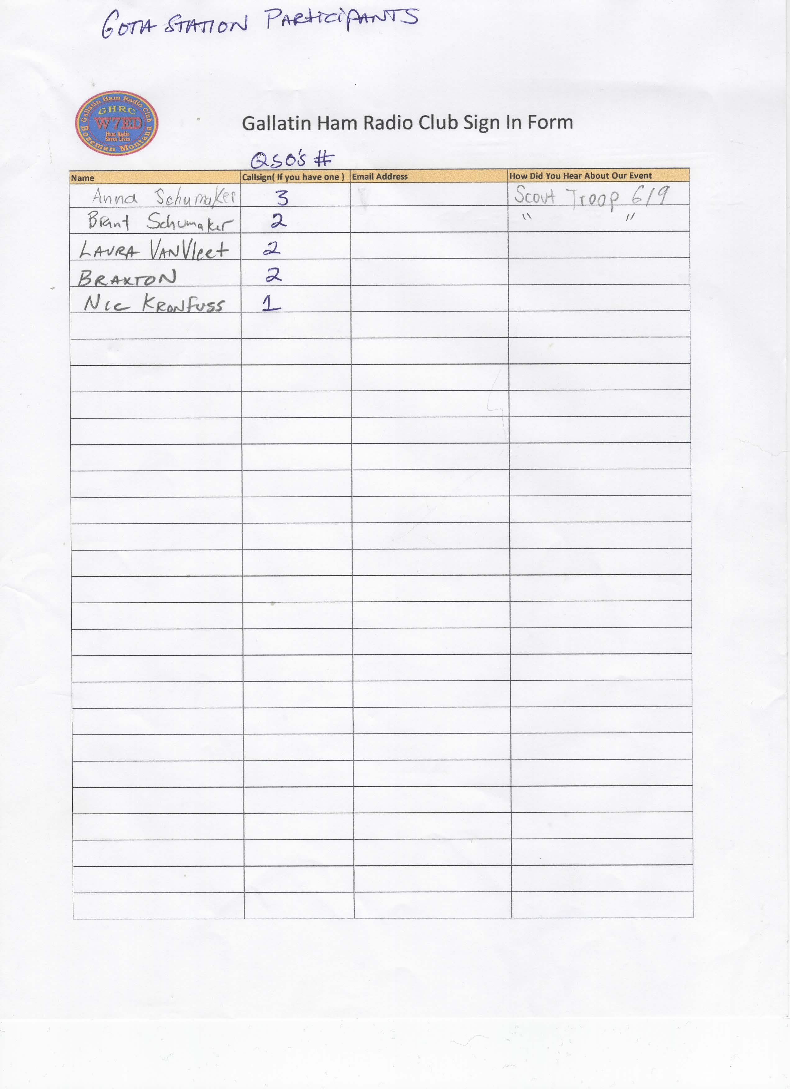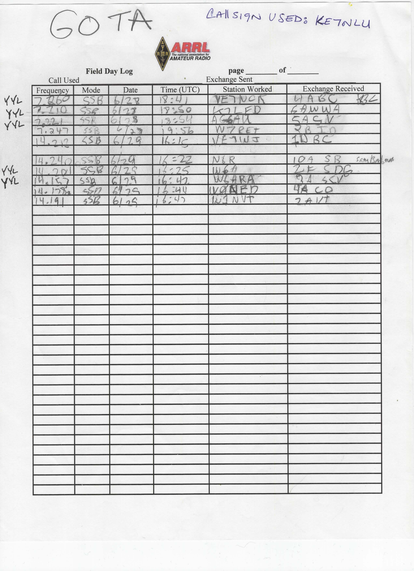
7.3.13.2. If a GOTA station is supervised full-time by a GOTA Coach, a single 100-point
bonus will be earned.
7.3.13.2.2. To qualify for this bonus, there must be a designated GOTA Coach present
and supervising for at least 10 contacts.
We had a full time GOTA coach at the GOTA station,Eric, KE7NLU.
7.3.14. Web submission: A 50-point bonus may be claimed by a group submitting their Field Day entry via the https://field-day.arrl.org/fdentry.php web app.
We will submit via web app.
7.3.15.1. A 20-point bonus (maximum of 100) may be earned by any Class A, C, D, E, or F
group for each participant age 18 or younger at your Field Day operation that completes at
least one QSO.
We had 3 YYL’s that made a total of 5 QSO’s. Anna and her sister(Scout Family) and Braxton was brought by one of our club members.
7.3.16 Social Media: 100 points for promoting your Field Day activation to the general
public via an active, recognized and utilized social media platform (Facebook, Twitter,
Instagram, etc). This bonus is available to bona fide amateur radio clubs and Field Day
groups that welcome visitors to their operation. Club websites do not qualify for this bonus.
We did utilize Facebook. We posted on our GHRC page and also to the ARRL Field Day page, the ARRL page and the ARRL MT Section page. We used the hashtags: #ARRLFD #ARRL #hamradio #amateurradio #GallatinCounty We did have a couple of people who saw our posts and came out to get some questions answered about a radio and to grab some free food at the BBQ.
7.3.17 Safety Officer Bonus: A 100-point bonus may be earned by having a person serving
as a Safety Officer for those groups setting up Class A stations. This person must verify that
all safety concerns on the Safety Officer Check List (found in the ARRL Field Day Packet)
have been adequately met. This is an active bonus – simply designating someone as Safety
Officer does not automatically earn this bonus. A signed copy of the Safety Officer Check
List must be included in the supporting documentation sent to ARRL HQ in order to claim
this bonus.
We have the documentation signed by Sally KJ7WFN. See Attachment-Safety Officer Checklist FIELD DAY 2025.
7.3.18. Field Day Responsibilities Bonus (new for 2024): A 50-point bonus may be earned
by having a person ensure that the Field Day site is free of hazards, and that safety
precautions have been taken throughout the entire event, as well as providing a point of
contact to the visiting public or served agency officials. A signed copy of the Field Day
Responsibilities Check List must be included in the supporting documentation sent to ARRL
HQ in order to claim this bonus. Available to Class B, C, D, E, or F entries.
Not applicable to our Class A operation.
GHRC Field Day Participants: AT HOME Stations:
KK7CJV-SSB AI7DK-CW
KJ7WFN-SSB N7FLT-SSB
KJ7SSS-SSB/Digital
KD7TQM-Digital
KE7NLU-Digital
KE7SJZ-SSB
KK7NNE-SSB
KK7WZW & KI5AOB-SSB
NZ7W-SSB/Digital
KM7BCC-SSB
KK7WHW-Satellites
KF8CXA-SSB
N7DAY-SSB

