hashtag #ARRLFD
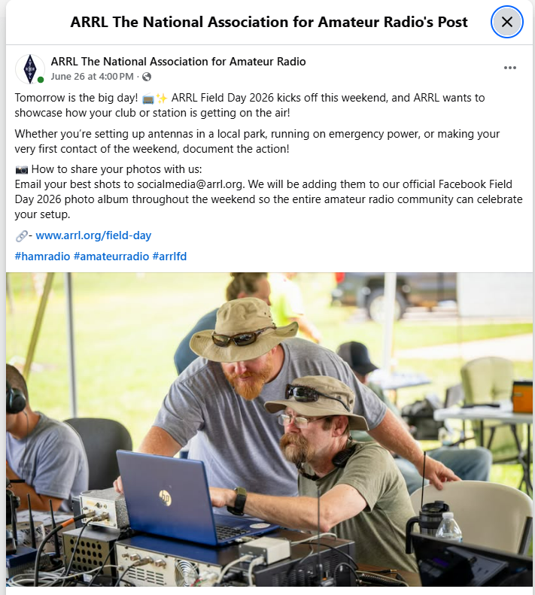

2. YOUTUBE : Dominate ARRL's 2026 Field Day!
https://www.youtube.com/watch?v=0XR2aJLogwI
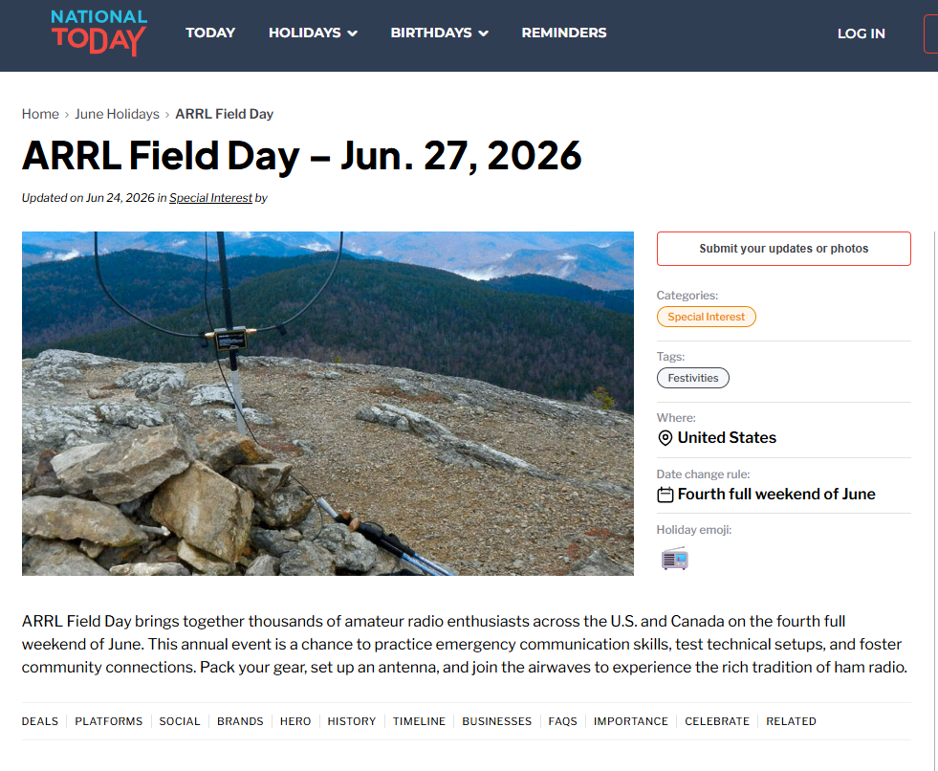
https://nationaltoday.com/arrl-field-day/
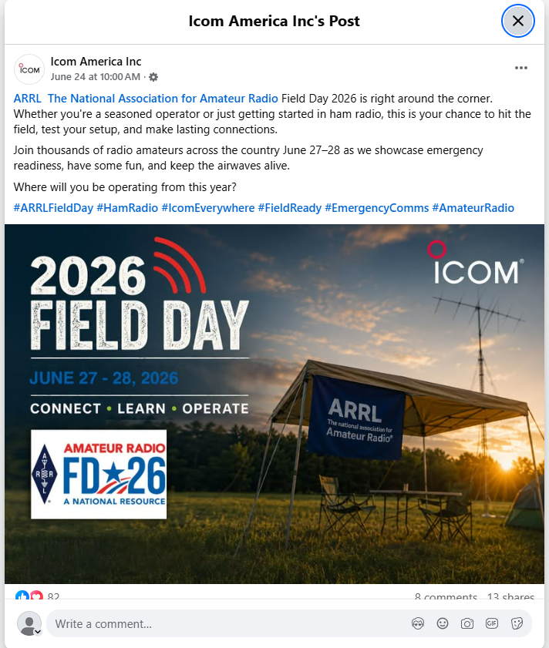
ttps://www.facebook.com/IcomAmericaInc/posts/arrl-the-national-association-for-amateur-radio-field-day-2026-is-right-around-t/1328231179499861/

