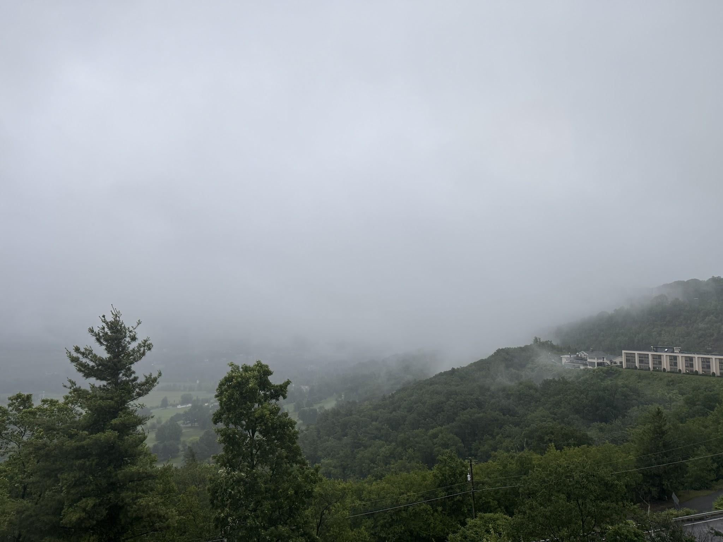
An Early Morning Fog Sets in at Jim Thorpe on the Way to Penns Peak FN20DV

June 2025 VHF Contest Summary- AA2SD/R Roves from the Poconos Mountains to Lancaster PA

AA2SD/R Rover -June 16 2025 - Thanks to all that worked me from the Poconos and the ride down into Lancaster. The driving was white knuckled for two days, with constant rain, late evening fog and limited visibility in the morning. Despite the setback with travel conditions I was able to make (5) grids in total. I tested a new Grid in Lancaster, located at the Linville Hill elementary school set in the picturesque Lancaster County which proved to be a great spot at FM19XX with a 700 foot elevation. The weather was a definite factor in travel time due to the constant rain and mist. I logged a total of 474 miles over the weekend including the drive home.

Band Condition on 6 Meter with Enhanced Propagation. The band conditions on Saturday and Sunday were excellent on 6 Meters, and I worked multiple stations from Florida with my Halo Antennas. I was able to work a number of stations on the move from the Poconos to Lancaster while using my digital recorder. The shingle Halo on the roof rack proved to be effective with this enhanced propagation,

1296 Mini Looper Test with My Roof Rack - My 1296 mini looper test proved to be a success with (4) contacts, 3 with W3CCX and 1 with N3RG on 1296. This small looper sits on my roof rack and I watch from my inside sunroof to align the antenna. I also deployed a small ELK beam 2M/440 on the rooftop, which proved to be very effective and kept me dry in the cabin during the rain. The Elk is an ultralight compact log periodic antenna with dual bands. You can learn more about Elk Antennas here https://elkantennas.com/

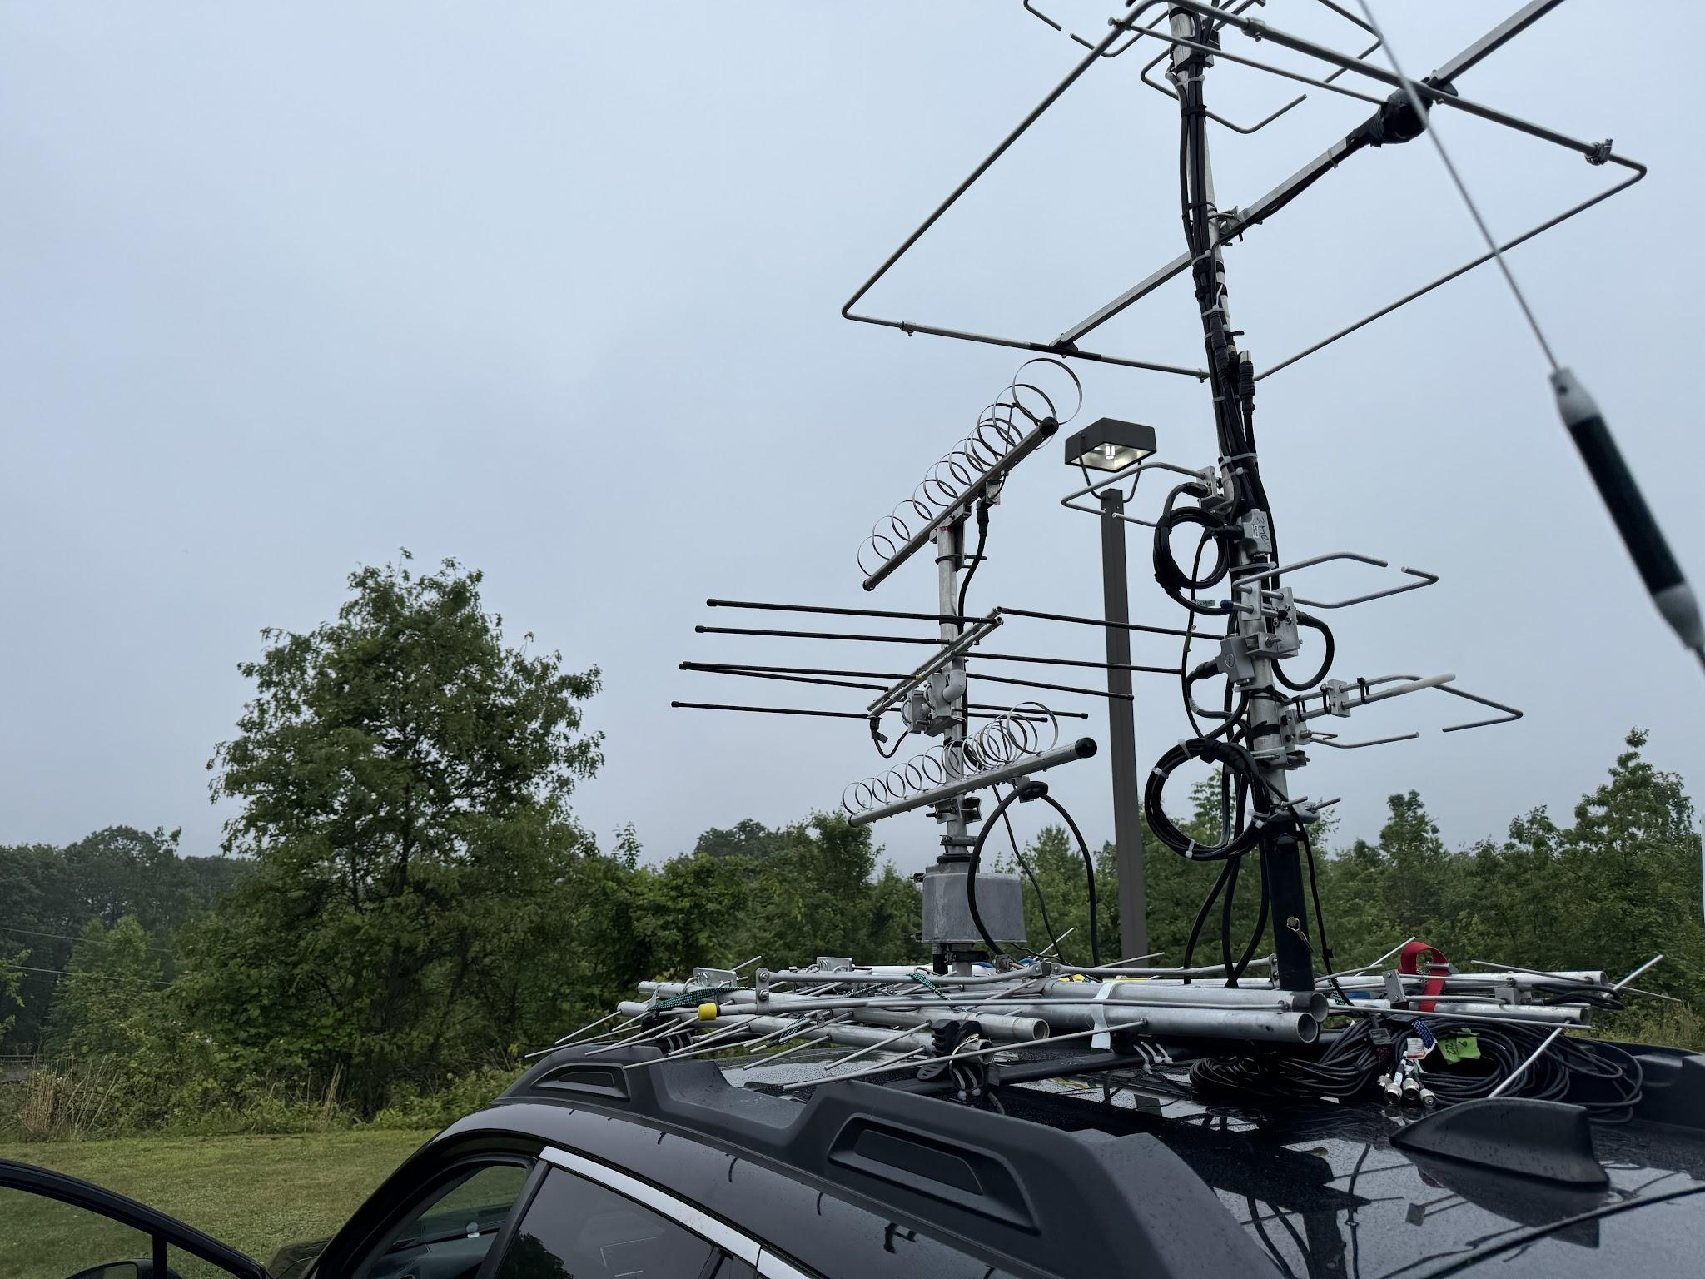
New Dual Stack Antenna Set up with loopers and a small 2 /440 Elk Beam

Water Issues with Connectors Proved to be the Achilles Heel. - The constant downpours and misting while driving created havoc with (2) antenna connectors. I had double taped these connections, but can use some advice from fellow Pack Rats on how to waterproof a N connectors that will survive a weekend of rain and driving in the wind at 60 MPH for hours.

Dual Stacked Halo Set Ups Proved Out - During this trip I tested (3) sets of Dual Stack Halos from a company named Freqteser. The Dual stacked mini halos were used on 2, 440 and 222 Mhz. The dual stacked halos worked well for most contacts as long as I reached higher elevations. This saved me significant time from setting up antennas at each location in the driving rain. I also worked a number of roadside contacts, and on the move
contacts with the halo set ups. You can view the Freq Tester sire here for halos. https://www.freqtester.com/

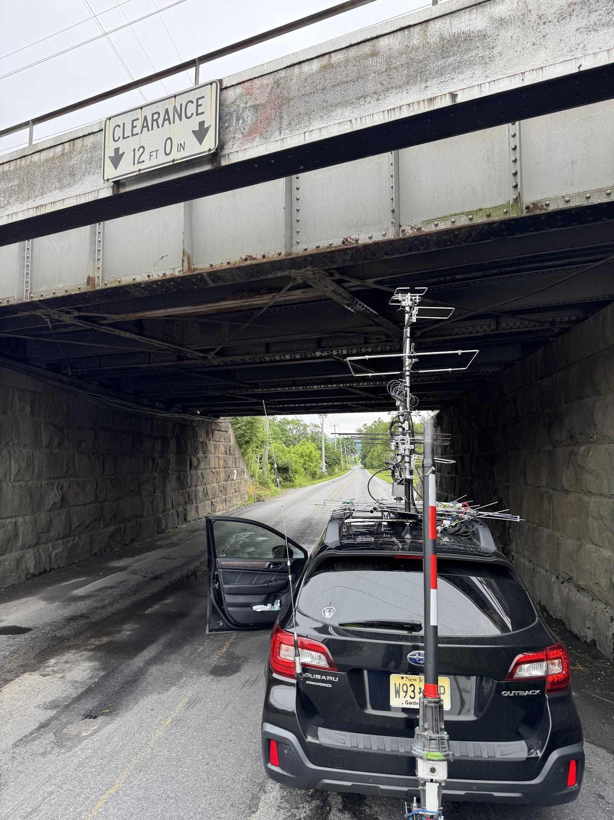
A close call with a local bridge overhead, I had to Get Out and Check this, good thing I lowered my mobile to 11 feet from Prior Rover due to this concern.
Grids and Rove Summary

- 474 Miles Logged in 2 Days (5 Grids Visited)
- The Knob FN21 HC - (5) miles north of the Pack Rats Set Up (good overlook 1711 ft elevation)
- Butler Mountain Senior Living Center FN10XX (good overlook 1677 Feet elevation)
- Lookout Motor Lodge FN11WA
- Penns Peak Roadies FN20DV 1544 Feet
- Linville Hill Elementary School FM19XX
- QSOs in Log : 163 (all phone with only 4 FT8) tota 179 includes testing before contest Submitted Score 7,700
- 50 Mtrs - 74 Contacts, 144 - 36 contacts, 222 -21 contacts, 420 - 28 contacts - 1296 - 4

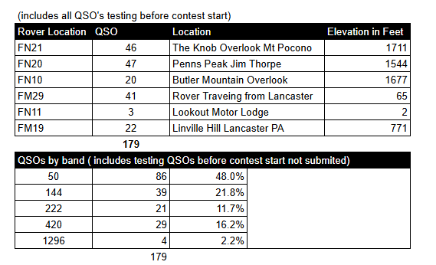
As a Rover it is a challenge to time your overlook locations and get your antennas set up in time for the contest and stay on schedule for contacts. This contest was a major challenge with weather conditions, being especially cautious with driving in mountain fog in the morning and evenings. I was pleased to still make (5) grids out of the planned (6) grids. A special thanks to the Pack Rats on the mountain, and to Jim KC3BVL rover coordinator, the burner phone contact and coordination was excellent with W3CCX.

I look forward to working with you during the upcoming August 222 and Up Contest this Summer with KE5NJ from the 100 Mile Overlook in Jim Thorpe PA.

AA2SD/R Rover Pulled over and Taking a Break in Lancaster PA
