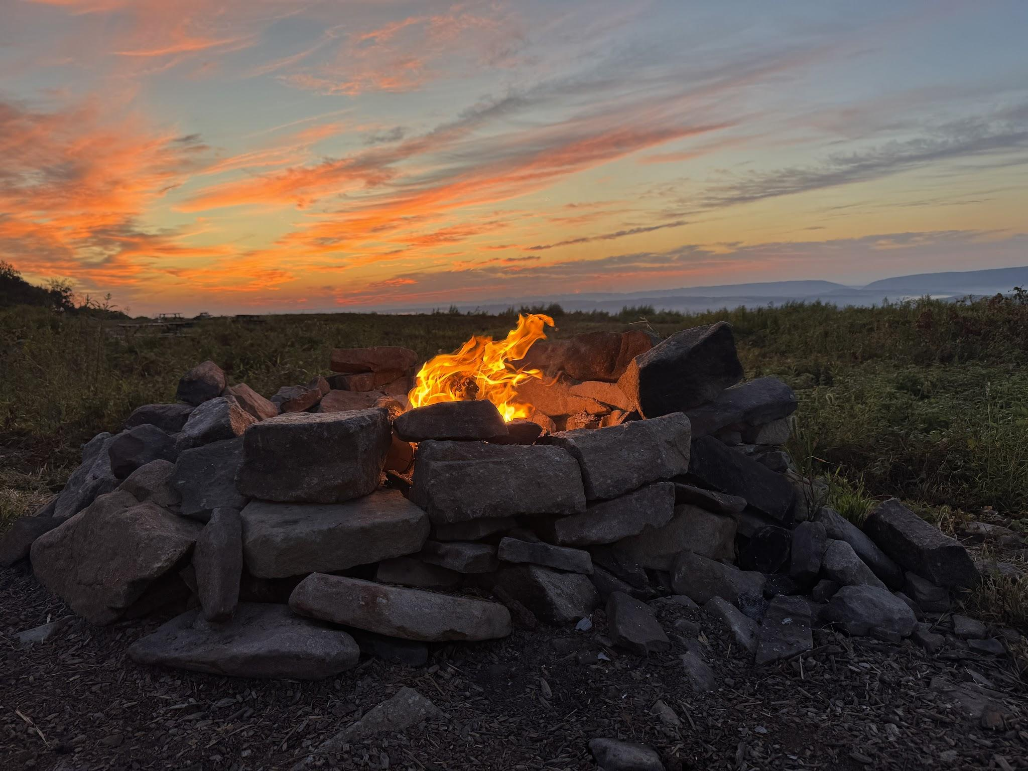
An Early Morning Camp Fire at Base Camp During an Early Morning Start FN20 100 Mile Overlook KE5NJ/R and AA2SD/R

AA2SD/R and KE5NJ/R Pack Rat Rovers Team Up for the September VHF Contest in the Poconos.

Pocono Mountains Sept 13-15th 2025 AA2SD/R KE5NJ Rover
Saturday Contest Start - We started this Rove at the beginning of the contest with (2) different overlooks, with Chris KE5NJ/R located on FN20 on top of the 100 Mile overlook at FlagStaff Mountain. I started at Big Pocono State Park FN21 for the start of the contest at 2200 ft elevation. Overall Conditions for 2 and 6 Mtrs appeared to be generally flat for the entire contest. During the first (4) hours I worked 50 QSO’s all on the phone. My microwave system switch was not working so I moved back to a (4) band rover only. During the evening at base camp we operated FT8 using a smaller moxon antenna and 2 mtr beam.

Sunday We Grid Circled to the following Locations as Tandem Rovers
During Sunday (2) Rovers Operated in Tandem - as a unique experience during Sunday Chris and I operated as (2) separate rovers in each grid square we visited (3) additional Grid Squares from overlook areas only. Operating in this fashion we will be able to pick up our count of contacts as operators could easily work (2) rovers on 4 bands from one grid location. We visited (5) stops during Sunday to maximize our foot print.

Grid Circle Plan for Rovers During Sunday
- FN20 - 100 Mile Overlook Starting Point 1500 Ft
- FN10 - New Location at 1800 feet across from a Dollar Store in Hazelton PA
- FN11 - Lookout Motor Lodge in Drums PA .operated from the parking lot overlook
- FN21 - Pensacone Mountain Fire House Location open field 1800
- FN20 - Penns Peak Roadies Restaurant 1500 Feet

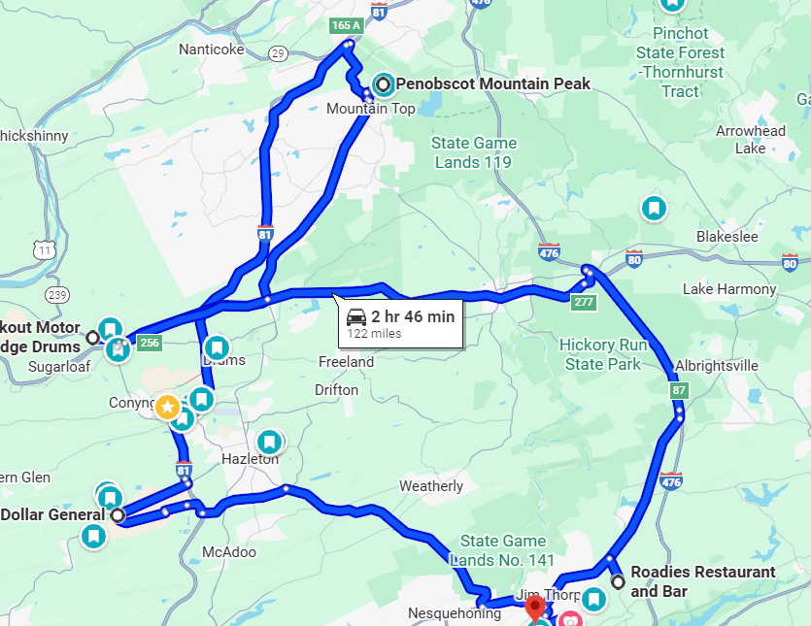Grid Circling Plan During Sunday allowed us to hit (4) Grids as Tandem Rovers all from Overlooks in the Pocono Mountains

Base Camp Set up at the 100 Mile Overlook - We set up base camp on top of a camping ridge located in Jim Thorpe Pa at 1500 feet. We used this position to operate in the evening on FT8 and regroup for the next day. As part of our Roving and Camping experience my XYL Donna had prepared a full on catered camping menu for each evening, along with a healthy breakfast to power us for the day. We enjoyed steaks on the grill, home made chili, western omelets and flap jacks for breakfast. We also would like to thank Andrea K2EZ/R Rover for coming by in the evening with a friendly and informative visit with us and enjoying some home made Chili over the open fire at camp side.

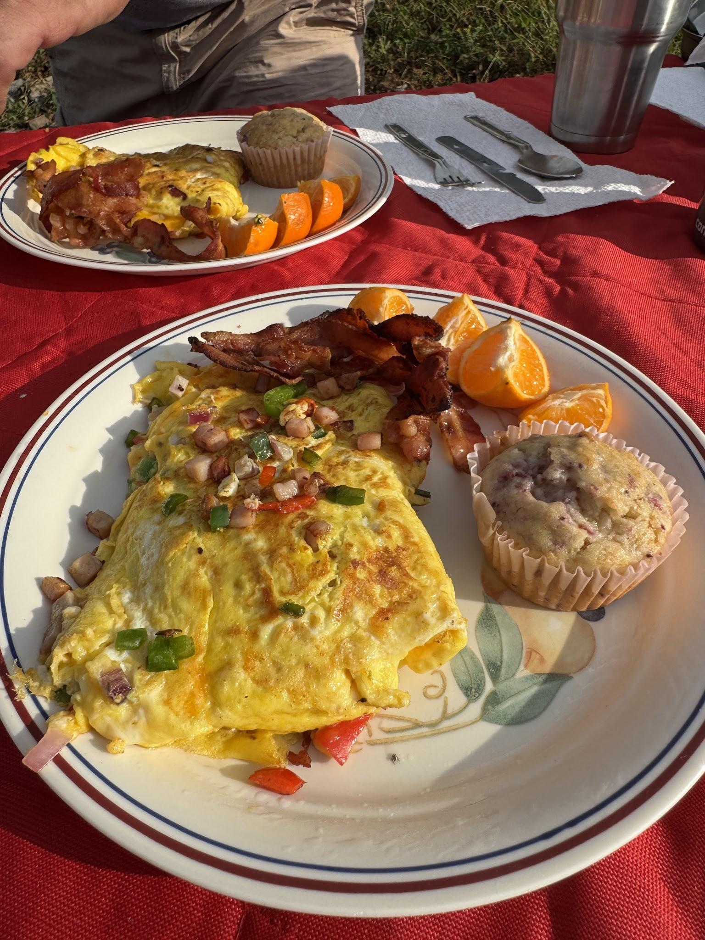
Western Omelettes prepared on the Mountain for the Rover

Base Camp Set up at the 100 Mile Overlook - We set up base camp on top of a camping ridge located in Jim Thorpe Pa at 1500 feet. We used this position to operate in the evening on FT8 and regroup for the next day. As part of our Roving and Camping experience my XYL Donna had prepared a full on catered camping menu for each evening, along with a healthy breakfast to power us for the day. We enjoyed steaks on the grill, home made chili, western omelets and flap jacks for breakfast.

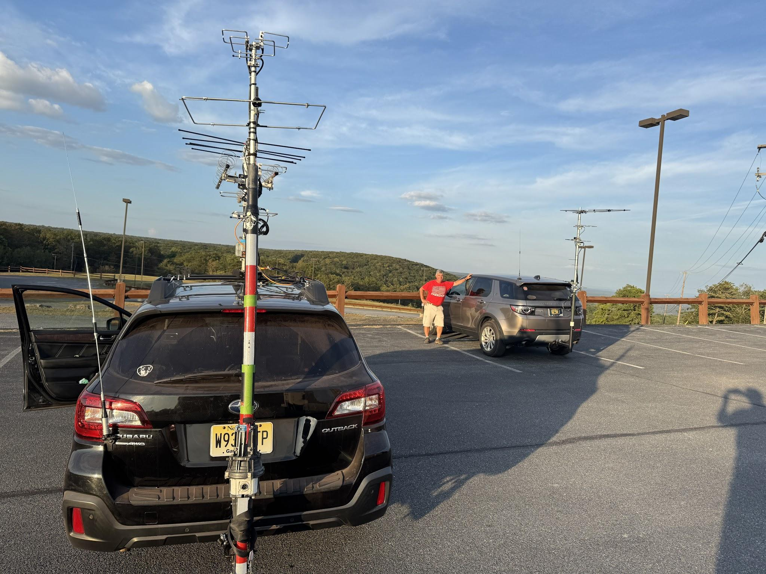Equipment Challenges for Microwaves - after testing my new bands three times, the switching arrangement did not function and I abandoned the strategy to run these bands. No changes to the system, and a driveway test, basement and net test before the rove checked out. I think the issue is vibration and we will trouble shoot this with Ray and it get it ready on the bands for the next Contest. Being flexible as a Rover and adjusting on the fly is important.

Summary Initial Results from the Trip - Overall this was an “epic first time Rover” trip we combined camping in a beautiful natural overlook, with great food, excellent camaraderie and learned how to Grid Chase as Tandem rovers. We also worked to trouble shoot some equipment issues and Chris came fully prepared with all of the camping gear and back up tools and essentials. Overall the band conditions were mediocre at best, and we did not enjoy any 6 mtr openings during the weekend. The entire focus was to have “Fun and Play Radio” and provide a target for other operators to help with their scores. Thanks to all that worked us during this week, and you can expect more Tandem Rover Plans from Chris and Myself during the upcoming events. We also would like to extend the invitation to any other local Rovers to join in with us as we plan our next Grid Chase Rove Plan.

Raw Score: 208 Qpts x 40 Mults = 8,320
Note: The raw score, QSO points and mult totals are estimates based solely on the individual log contents and are not used during subsequent log checking.

Start Date : 2025-09-13

CallSign Used : AA2SD/R
Operator(s) : AA2SD/R

Operator Category : SINGLE-OP
Band : ALL
Power : LOW
Mode : SSB
Station : ROVER-LIMITED
Assisted : NON-ASSISTED
Transmitter : ONE
Sent Exchange : FM29
Gridsquare : FN20

Name : Scott Dantis
Address : 31 Zion Drive
City/State/Zip : Berlin NJ 08009
Country : USA

ARRL Section : SNJ
Club/Team : Mount Airy Pack Rats
Email : scottdantis@gmail.com
Software : N1MM Logger+ 1.0.10888.0

Band QSOs Pts Grd Pt/Q
50 13 13 2 1.0
50 42 40 11 1.0
144 40 35 11 0.9
222 26 49 7 1.9
420 34 58 10 1.7
Total 155 195 41 1.3

Score : 7,995
Rig :

A special thanks to W2EA South Jersey Mountain Topper Group, all of the Pack Rats and Andrea K2EZ/R , Dave KR1Z, Mike WB2RVX, Ray N3RG, Donna my XYL for the excellent cuisine, and all other Rovers and operators in support of our efforts.

Please watch the video at the following lin

73
Scott AA2SD/R and Chris KE5NJ/5 Rover

