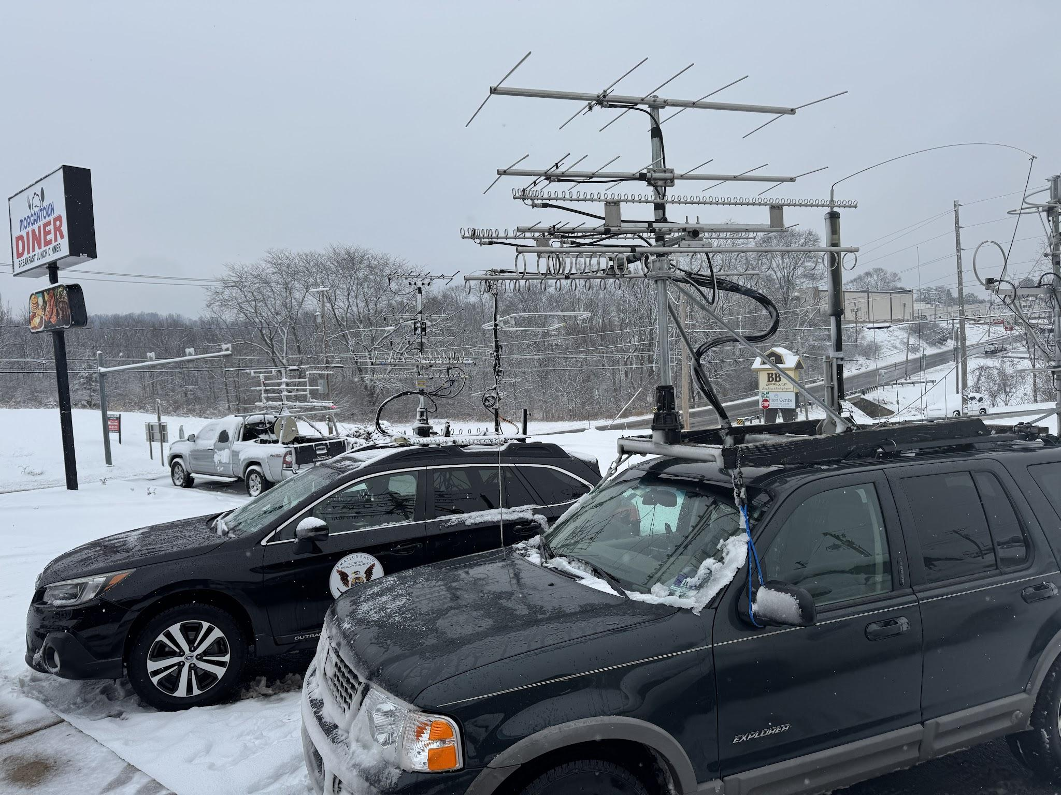
AA2SD/R Scott, K2EZ/R Andrea, KG6CIHR/R Chris meet up a the Morgantown Diner with Len N3NGE and Bill K3EGE before the contest start

AA2SD/R Completes The Jan VHF 2026 Contest Rove Visiting Grids FN20, FM10, FM19, FM29 and Local South Jersey Pack Rats During Wintry Conditions

AA2SD/R Rover - November 17th -18th Jan VHF Contest - Early morning driving out to the Morgantown Location FN20 on the PA turnpike the Snow and Icy mix started, and at time the Turnpike was down to a crawling 15-20 MPH, as I made my way to to meet up with the other Rovers. This was an early indication of weather and things to come for this weekend. Saturday Morning I set at FN20 Sunnyside overlook at 800 ft with (3) Rovers, W3ICC/R Paul and Drex, K2EZ/R Andrea and K0BAK/R Pete KG6CIHR/R Chris was simultaneously set up on FN10 across from us at the start of the contest. KE5NJ/R Chris had to cancel due to a flu and was missed.
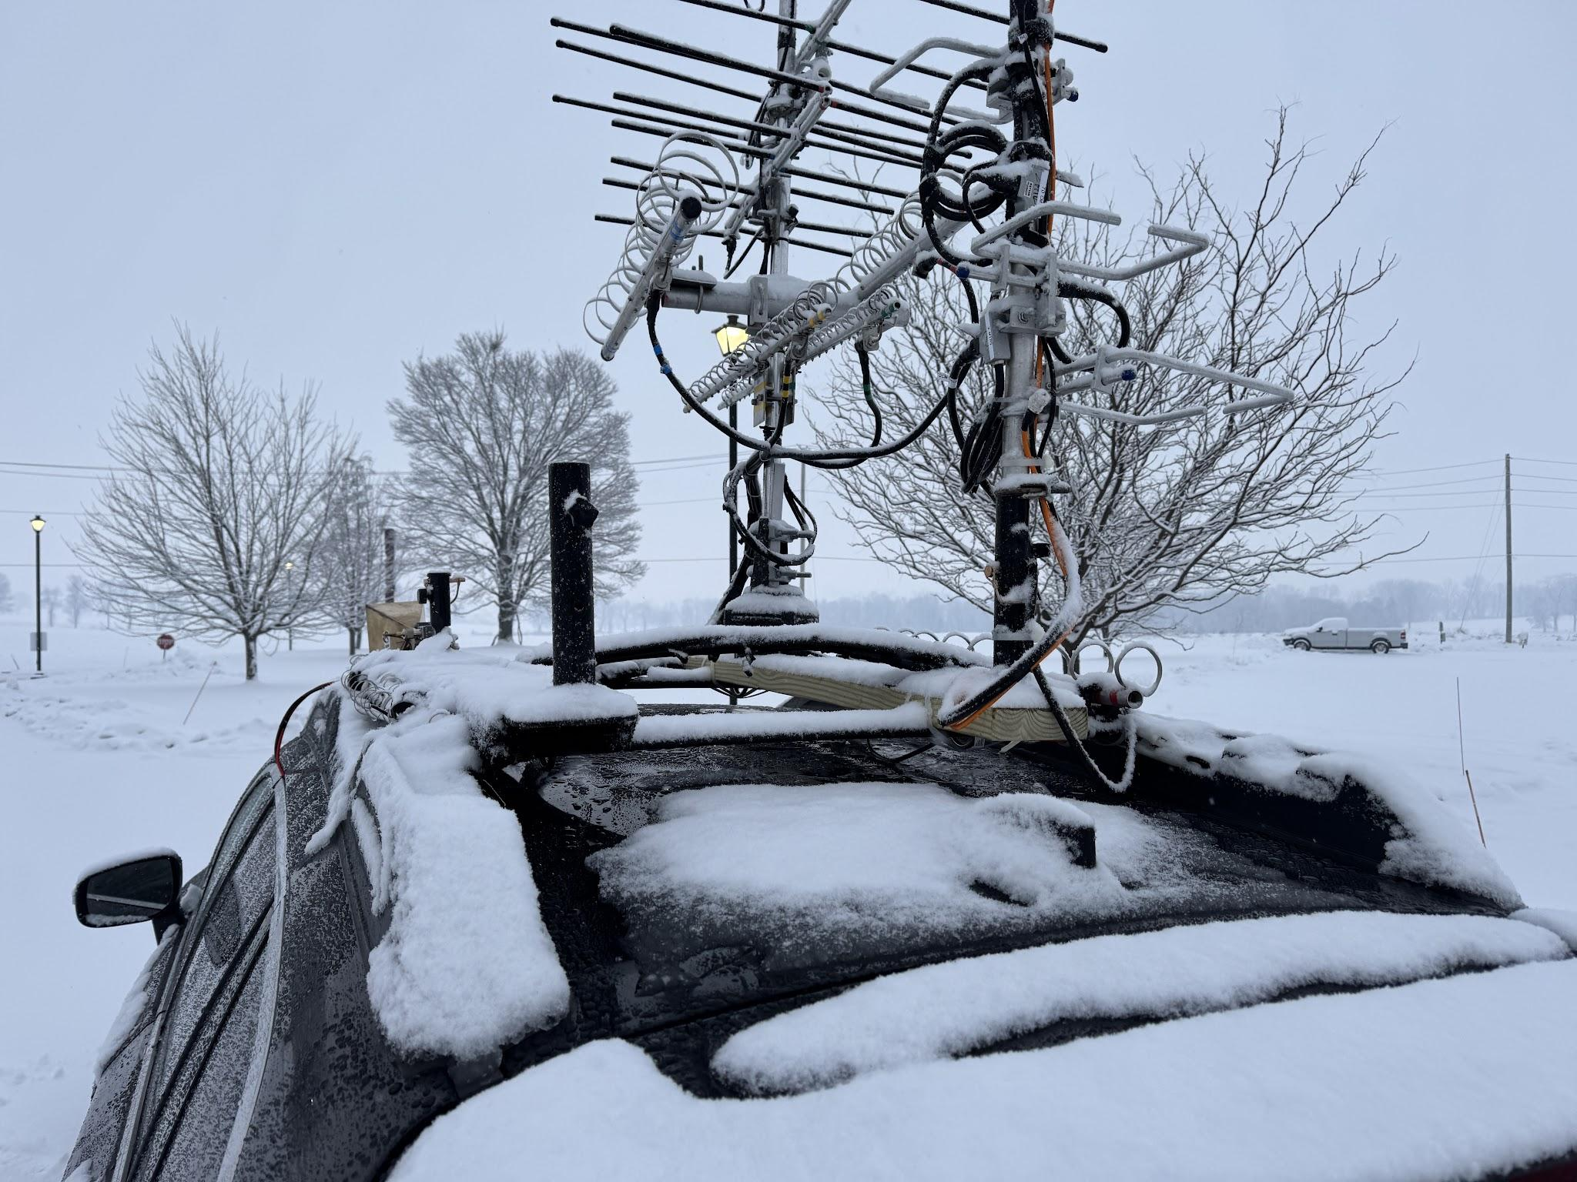
AA2SD/R experiencing wintry conditions throughout the entire contest

Part One Stop 1 FN20 Sunnyside Morgantown The best plans sometimes don’t work, and this proved out to be the case. We learned quickly that this did not work out well at all, as we overloaded each other, and created a much too aggressive SKED schedule that we could not stay on. We made the best of the time at Morgantown and worked with Len N3NGE, Roger W3SZ and Dave K1RZ Gary WA2OMY and several others. With stop 1 FN20 completed and behind schedule it was dark and cold as we negotiated our way to East Earl township and onto the Shady Maple RV Lot for placement.
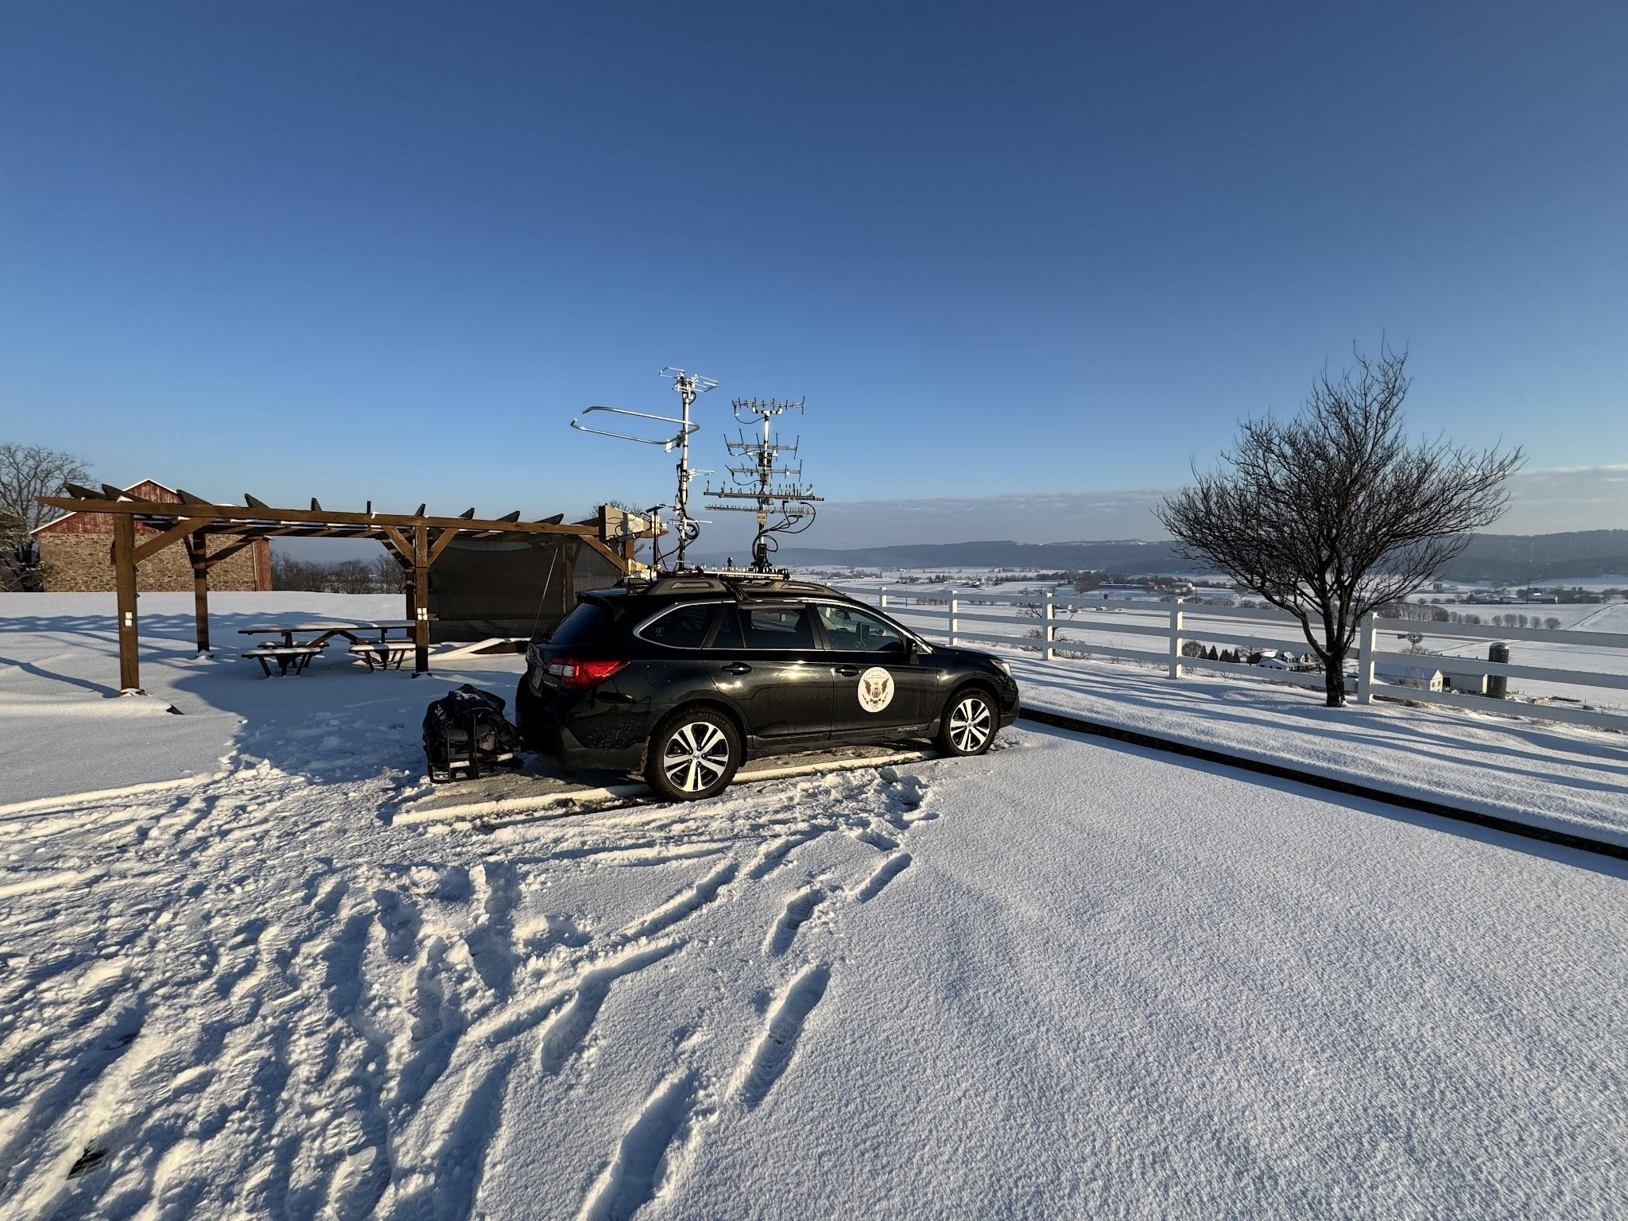
AA2SD/R positioned at FN20 Sunnybrook Overlook 800 ft at the contest start

Part Two STOP 2 East Earl Township/ Shady Maple FN10, I found the very back of the RV parking lot to work Roger and several others from this location. W3ICC/R Paul and Drex joined me after some time and set up, and Andrea K2EZ/R joined to make some easy Rover to Rover QSOs. At this point we were far behind schedule and the cold and darkness set in for a white knuckle drive to my hotel in Strusberg PA. I decided to forgo to work stations on the run back to the Hotel, and focused on my driving as I experienced black ice and snow fog on the way to the hotel upon arriving at 10 PM and called it quits for the day.

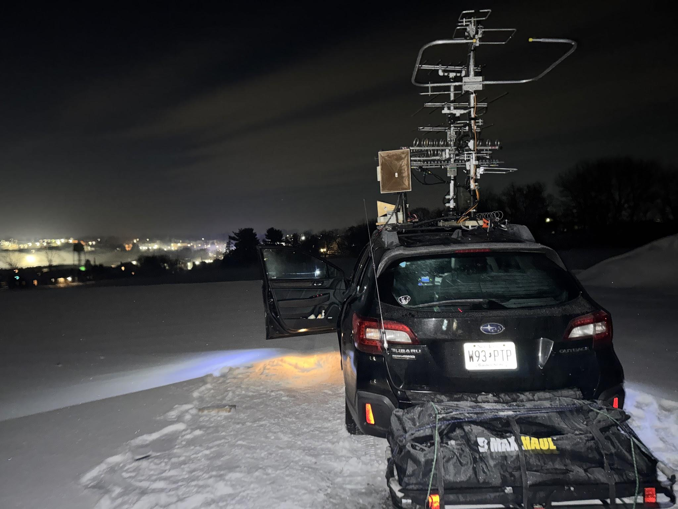
AA2SD/R working from the Shady Maple RV Lot Late Saturday evening

Part 3 Stop 2 FM19 Holiday Inn Hotel Site Strasburg I was meeting Chris Patterson W3CMP Rover early Sunday morning to exchange an antenna, we met briefly for the exchange and I thank Chris for taking the time to bring this over in the snow. I awoke to a driving wet snow in the parking lot and decided to load my recharged LIPO 4 batteries back in the rover after charging and try some parking lot QSO’s before Chris arrived. After cleaning the rover from snow, to my surprise this parking lot spot played extremely well, I worked several contacts on lower 4 bands and also worked some micros with my shoe box rover set up from the lot. I fished out this spot for over 2 hours and waited for the snow plows to come out on an early Sunday morning, which did not happen. It was time to move South to the new Antenna Site on Truce Road at 900 feet.

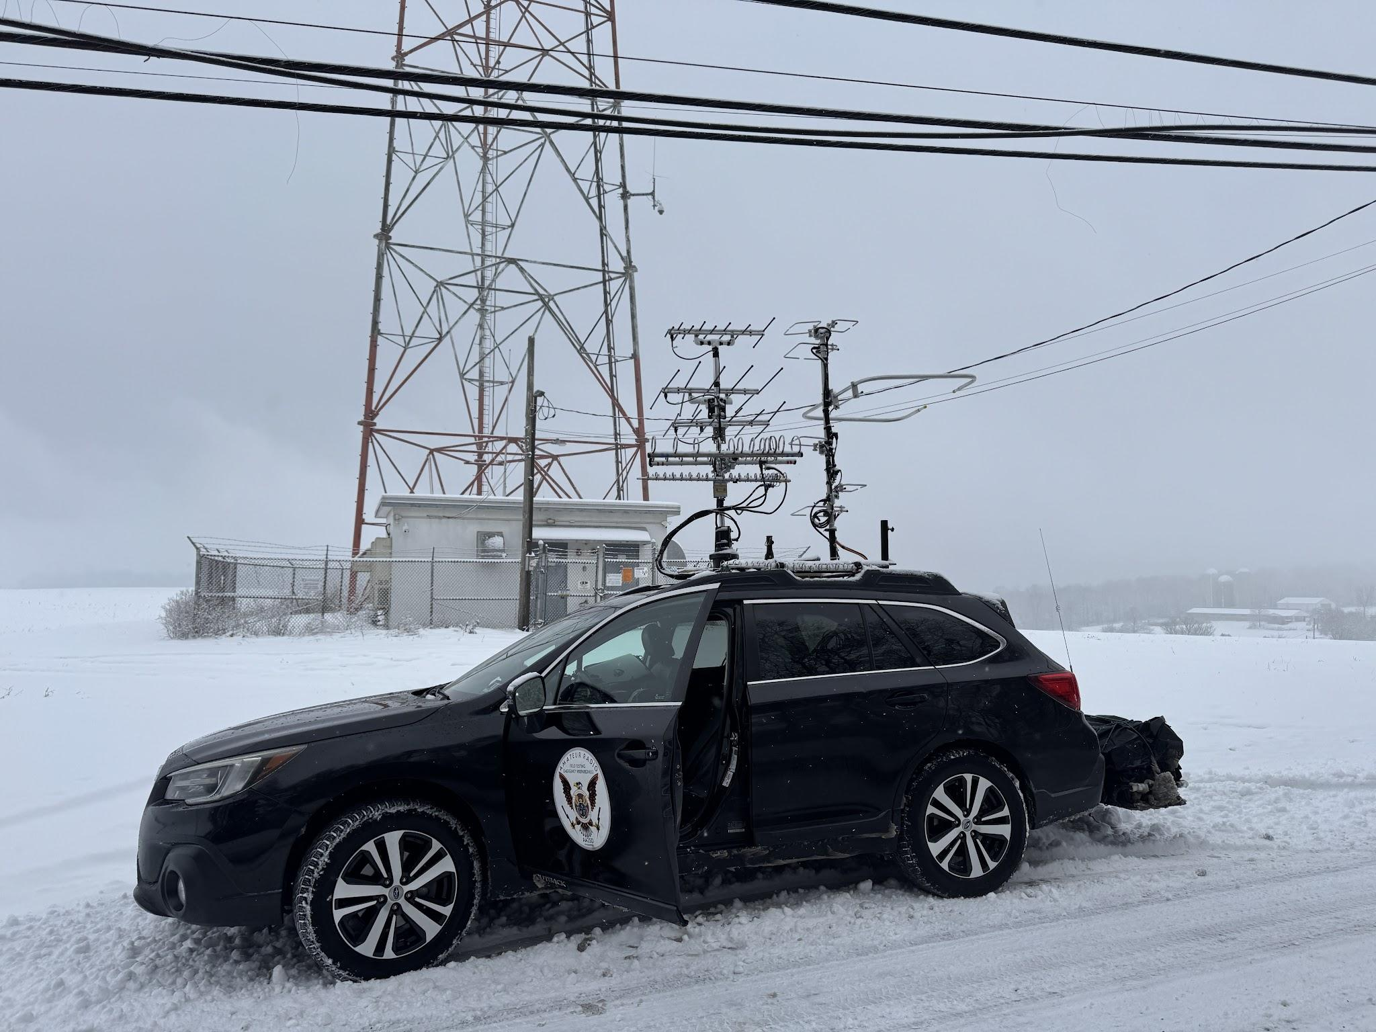
AA2SD/R Positioned at Truce Road FM19 900 ft early Sunday Morning working K1RZ

Part 4 Stop 4 Truce Road Antenna Site at 900 Feet FM19 This short drive according to Waze GPS was only 20 minutes totaling 11 miles due south into the rural farm area. Most of the roads traveled early Sunday morning were not treated and it was extremely slow going to stay safe.

Instead this drive took me well over 1 hour 15 minutes of extreme slow going on back country roads that were not treated or plowed. In some cases my tire tracks were the first ones to mark the fresh driven virgin snow. The positive is the Subaru Outback with all wheel drive had no problem handling the snow. I had planned ahead and installed a new set of Michelin Snow Tires called Michelin X-Ice. I read about these tires on Tire Rack, Michelin X-Ice Snow studless, and decided to invest in a set for winter roving. I would recommend these tires for anyone driving in this type of condition.

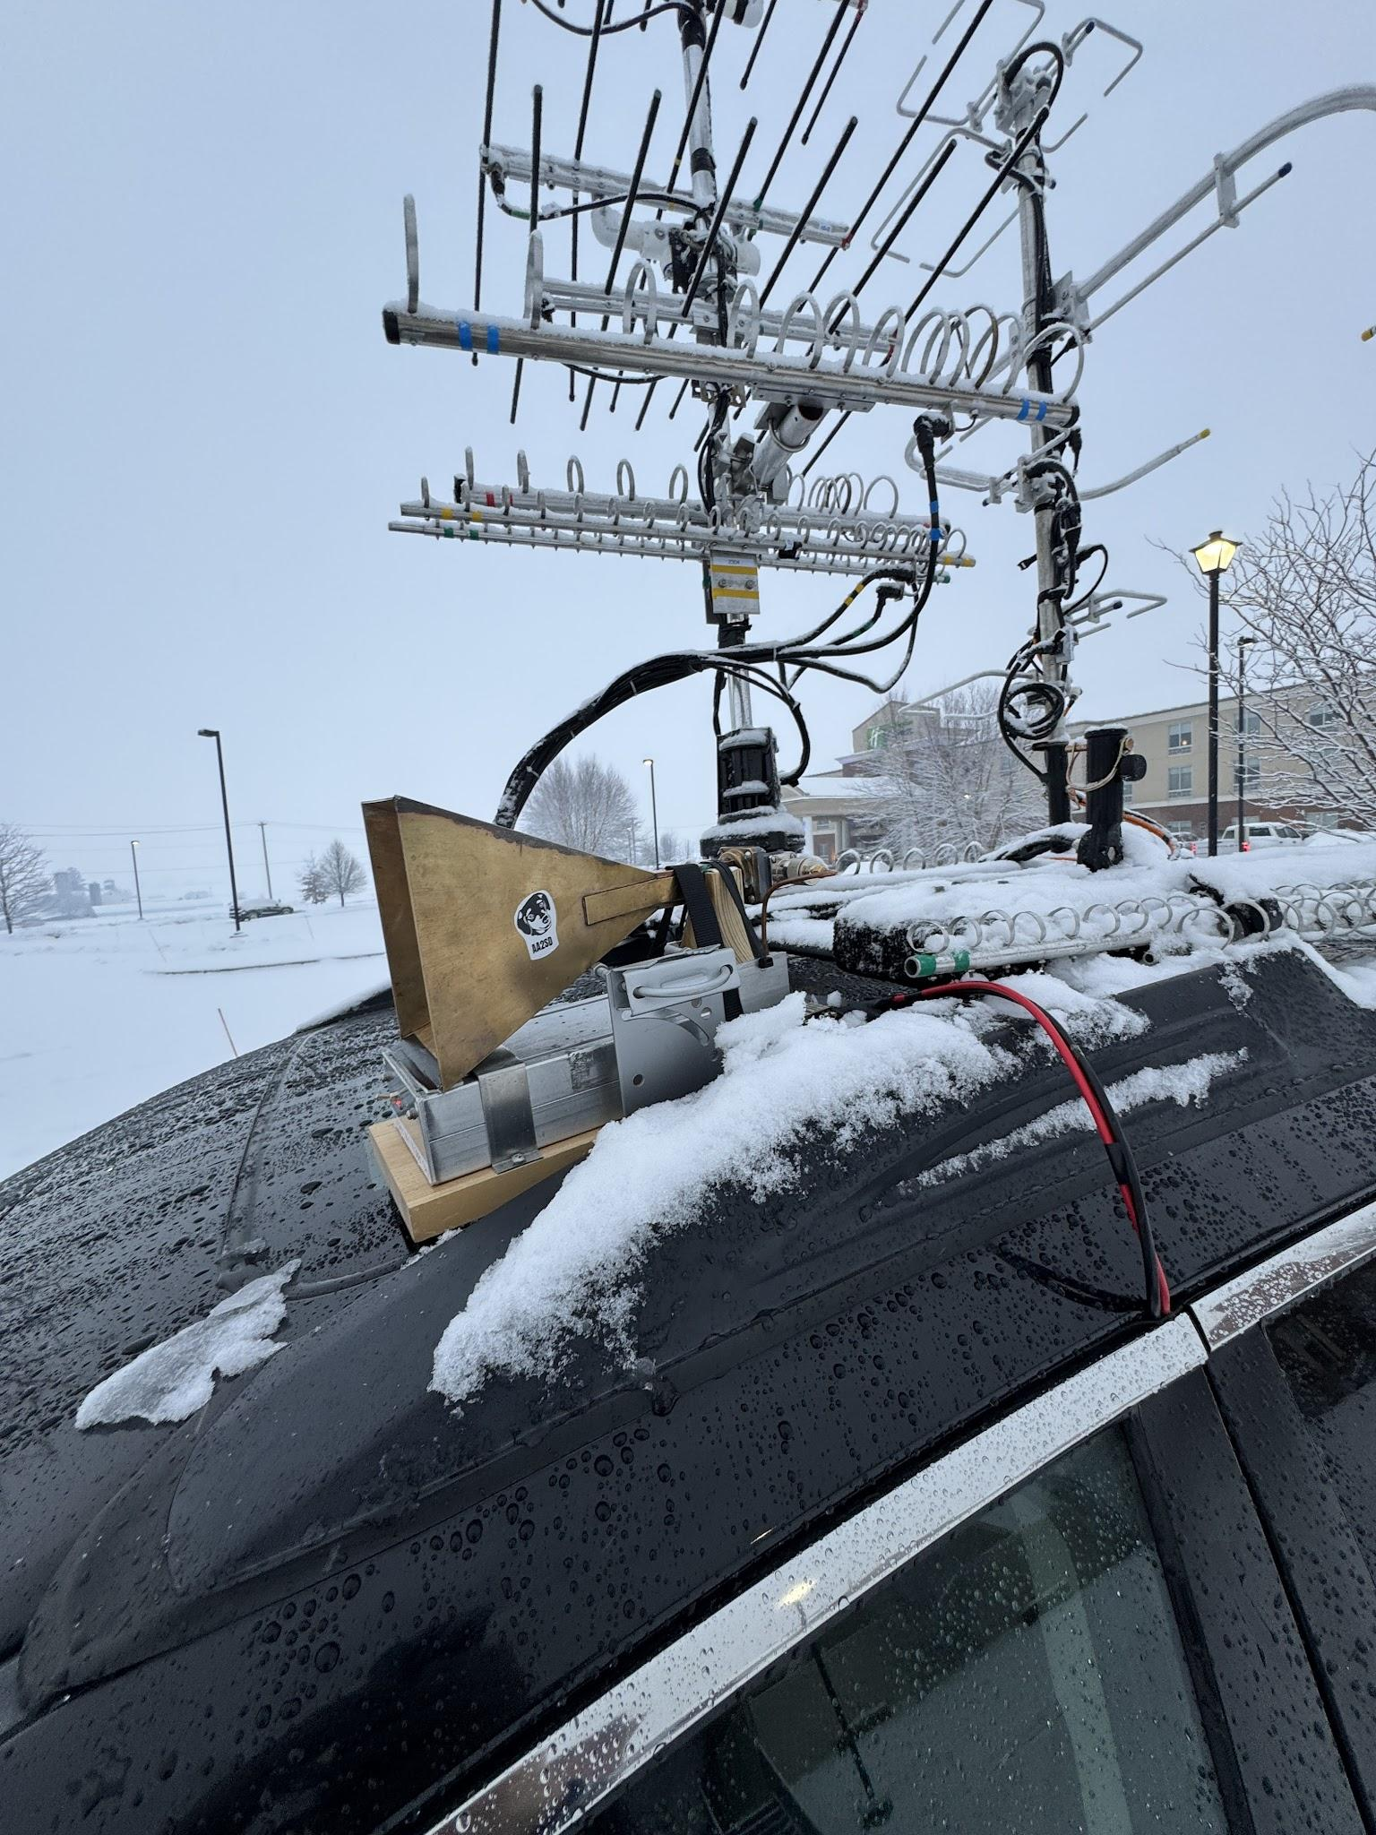
Working N3NGE Len with a show box 10GHZ from N3RG on 10 GHz Sunday Morning from FM19 Hotel Parking Lot

I arrived at the Truce Road antenna site and worked with Dave K1RZ and a few others, but this site did not play out as well as the earlier hotel site. It could have been that it was Sunday breakfast and Church time, and the bands were empty for me, or conditions had changed. I decided that after my long drive here and weather continuing to make an audible call and redirect to Mullica Hill NJ to work South Jersey Pack Rats. My country route path took me to a covered wooden bridge with a large “10 Feet Restriction” overhead. Which my rover could not make and had to re-direct again.

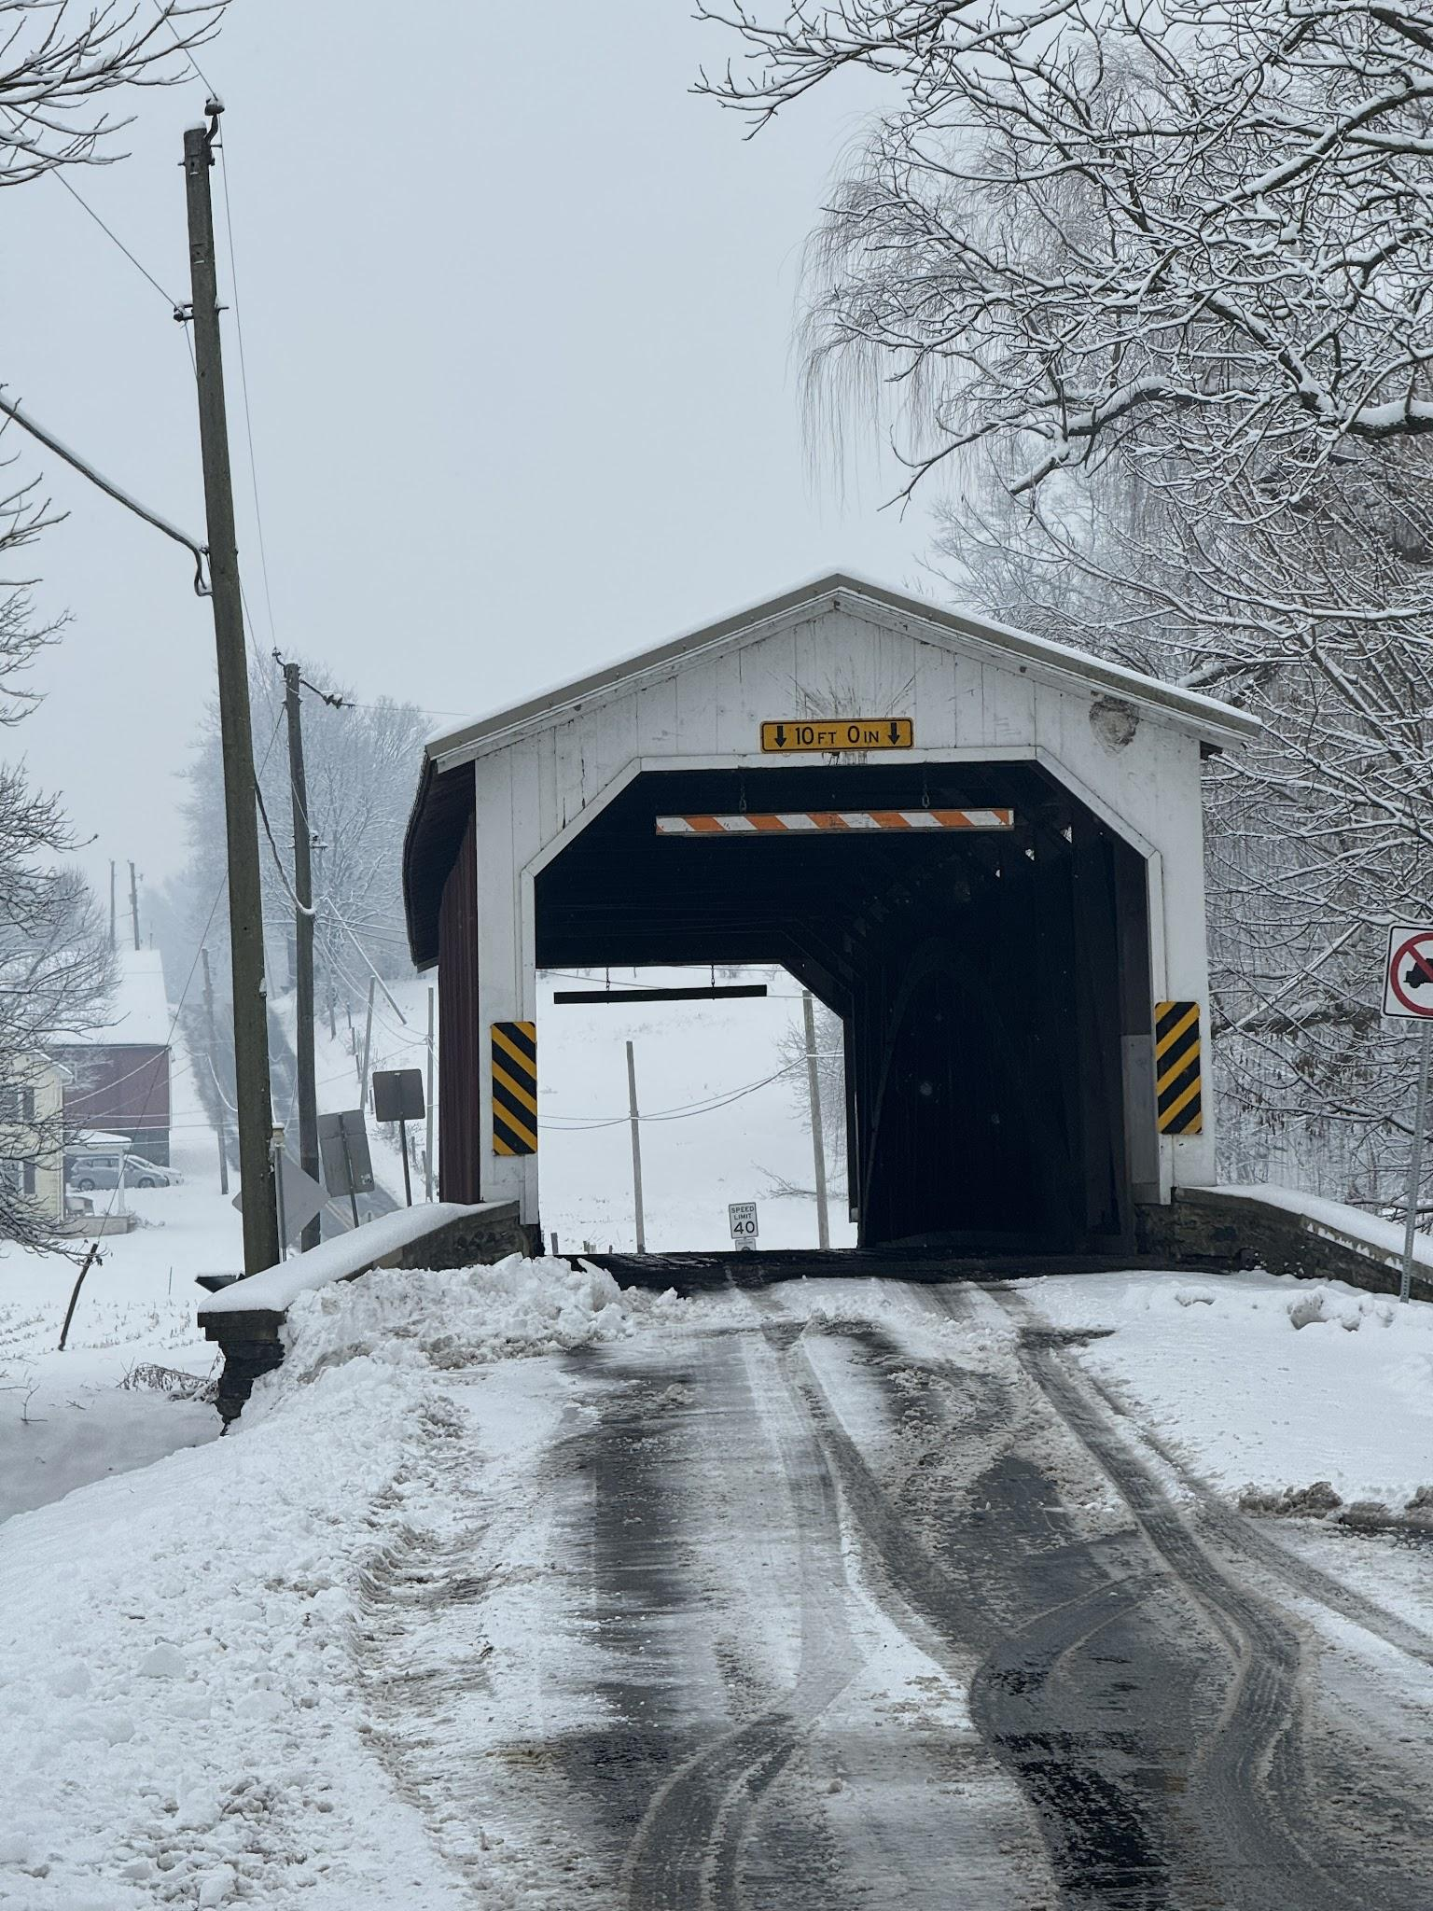
AA2SD/R heading to Truce gets turned around due to Antenna Height at this Bridge with only a 10 foot clearance, my antenna touched the wooden warning overhead bar.

This road took me through the tip of Maryland into Delaware and finally back onto 95 North to South Jersey. I switched antennas over to the stacked halos, and worked WA3NUF and several others on the drive back to New Jersey, although the weather continued to be very bad driving conditions.
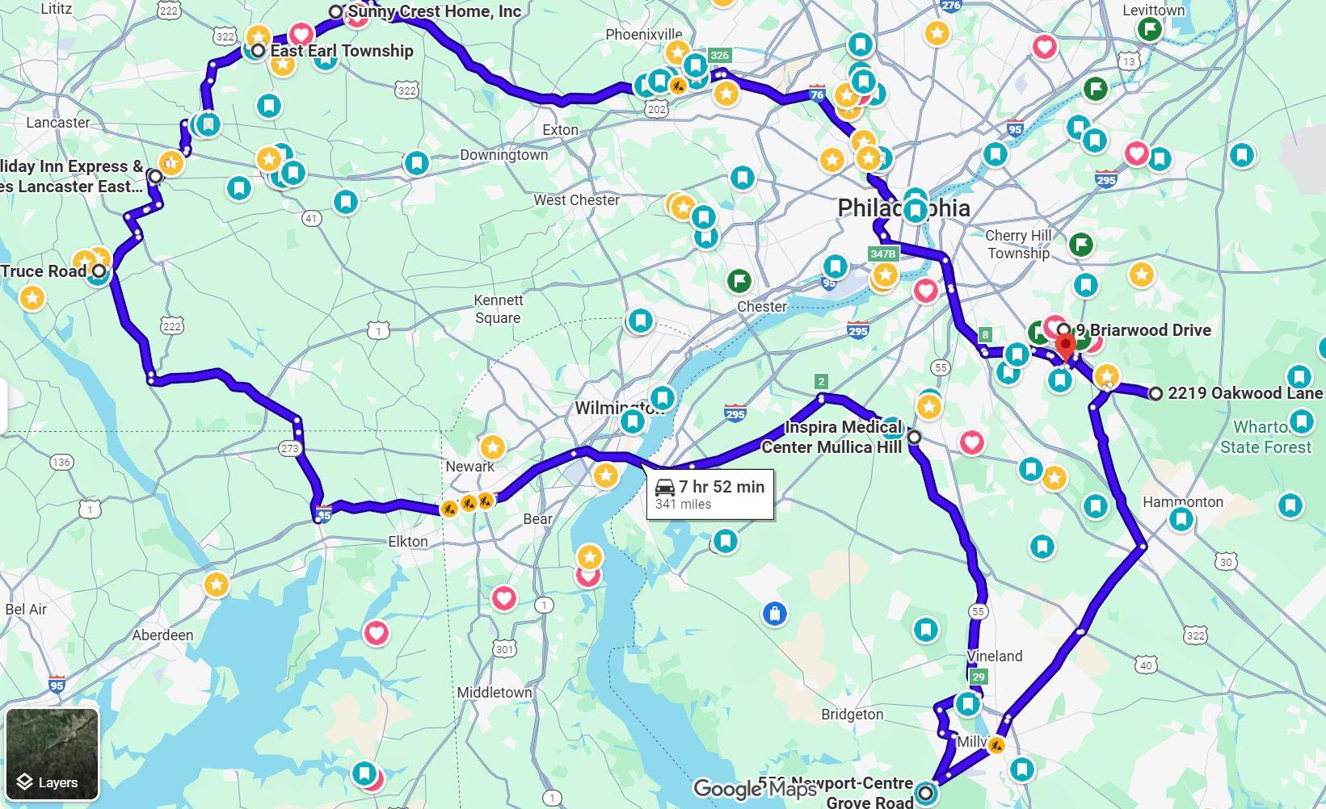
AA2SD/R Total Rove of 370 Miles completed during the Jan VHF Contest 2026 including a Southern New Jersey door to door microwave rove for locals.

Part 5 Stop FM29 South Jersey Mini Rove Mullica Hill, Millville, Atco and Voorhees NJ change the Playbook to a Driveway Rover for Microwave contacts Driving fatigue was starting to set in and I decided to take lunch at a deli, and re-direct to South Jersey, I now had a goal to finish early, have dinner with my XYL at 5PM and call it quits. The inclement weather played a big part in delays, and I personally had to re-direct my schedule to stay safe, I decided to change the playbook and become a driveway Rover taking the lead from Pete K0BAK, and personally visited WB2RVX, N3RG, KC2SGV and KC2TN for some great driveway microwave contacts. This strategy worked very well as I worked all stations on their available microbands, with Ray I worked him from a tree farm in Southern New Jersey at 3 miles.

Summary of the Jan Contest 2026 I clocked a little over 370 miles driven in 2 days all in very poor conditions. Fortunately I planned ahead for these driving conditions. I decided to use only a rooftop antenna set up only, with no antenna mast set up. This proved to work very well, as I deployed double stack halos for 222, 432, and 2 mtrs, and single halo for 6 Mtrs.

I did use 3 small ELK beams for 222, 2 Mtrs and 70 cm which played well with a rotor. During this rove I tested (2) 100 AMP LIPO 4 batteries and (1) 35 Amp AGM battery, along with a newly installed DC to DC charger which allowed me to charge on the way from the car alternator. Also the lighter batteries are easy to handle and came out to be charged in my hotel room. I can now drop the heavier AGM Batteries. I did experience a lot of N1MM connection issues for logging and CAT control with my PC which challenged logging QSOs. This must have been from RF in the vehicle, and I need to correct this or add toroids to the USB connections to the PC.
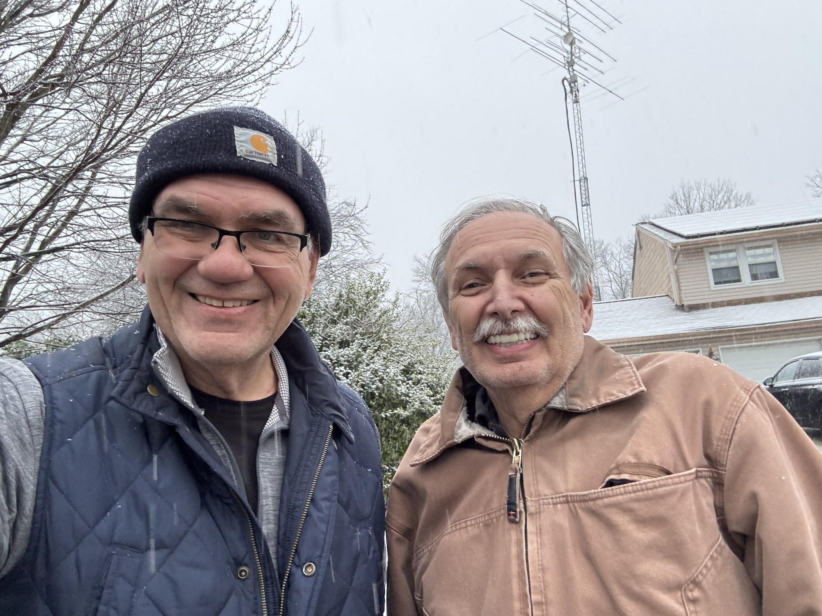
AA2SD/R Scott with Mike WB2RVX makes his last set of contact with 10 bands at the contest end with Mike

I also learned that you can make 10GHz and 5GHz microwave contacts from the roof rack with horns. This strategy worked very well, and I added longer IF cables and power cables for quick setup. I can improve on this for the next contest. I was manually switching BNC connectors which can easily be corrected with a switch.

I would like to thank all of the Pack Rat Rovers and Operators that participated in this "test case" of having multiple Rovers in one location at FN20 during the first day of the VHF contest. I was glad I stayed in the contest with some changes due to the weather conditions, and achieved my best score yet as a Rover with 10 bands.

Most importantly, I gained some additional Microwave operating experience and had fun. For me personally it’s not about the score, it’s the personal challenge to operate from each new location and support other Weak signal operators, and making new friendships in the hobby.

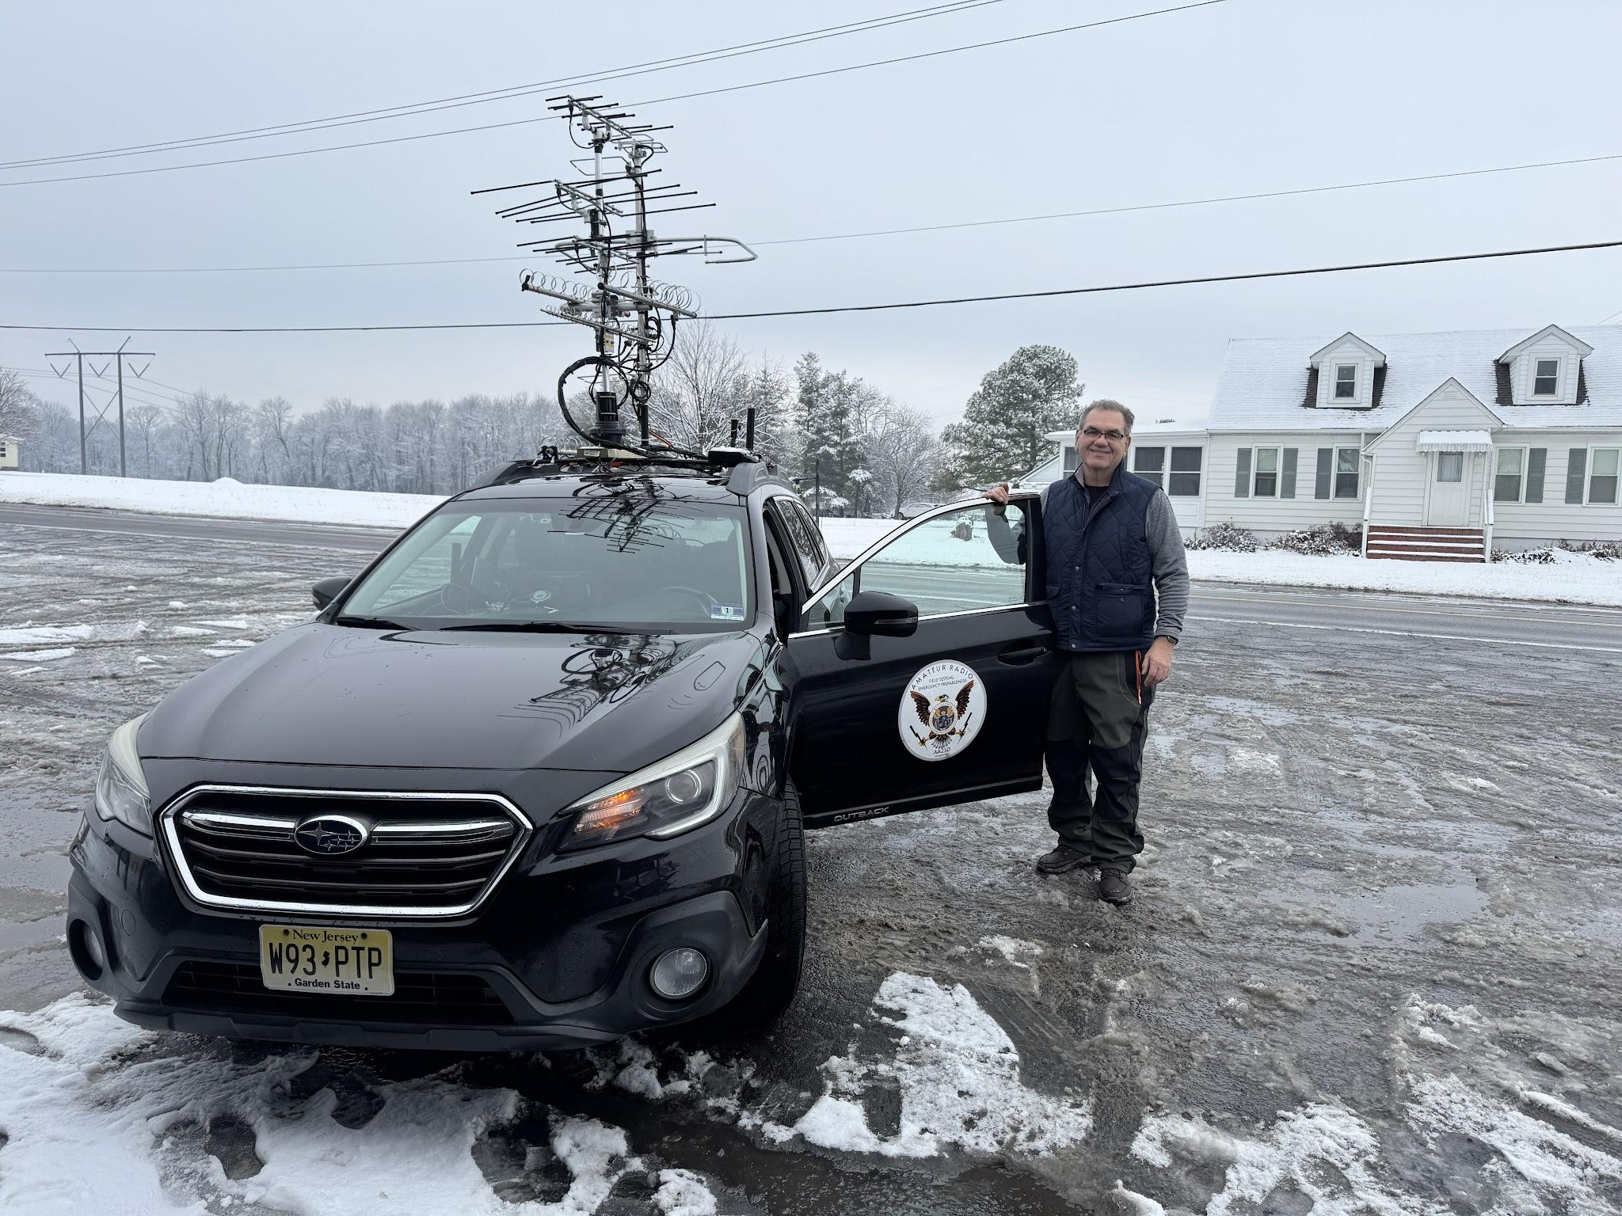
AA2SD/R making a lunch stop in MD at a local deli in route to Delaware and New Jersey
It's a testament to this Club, to have such an active base of operators and committed rovers in support of the Mt Airy VHF Club.

Look for me During the Spring Sprints Roving During 2026 !

View pictures here

https://photos.app.goo.gl/q8CDbu7mGRrXkTsH8

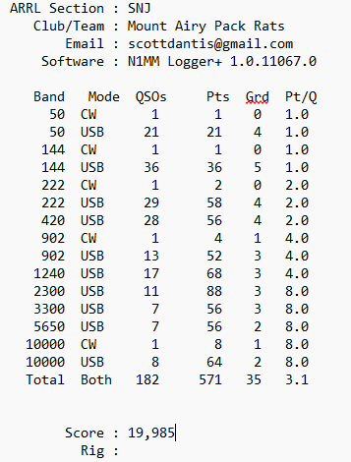

73
AA2SD/R
Scott
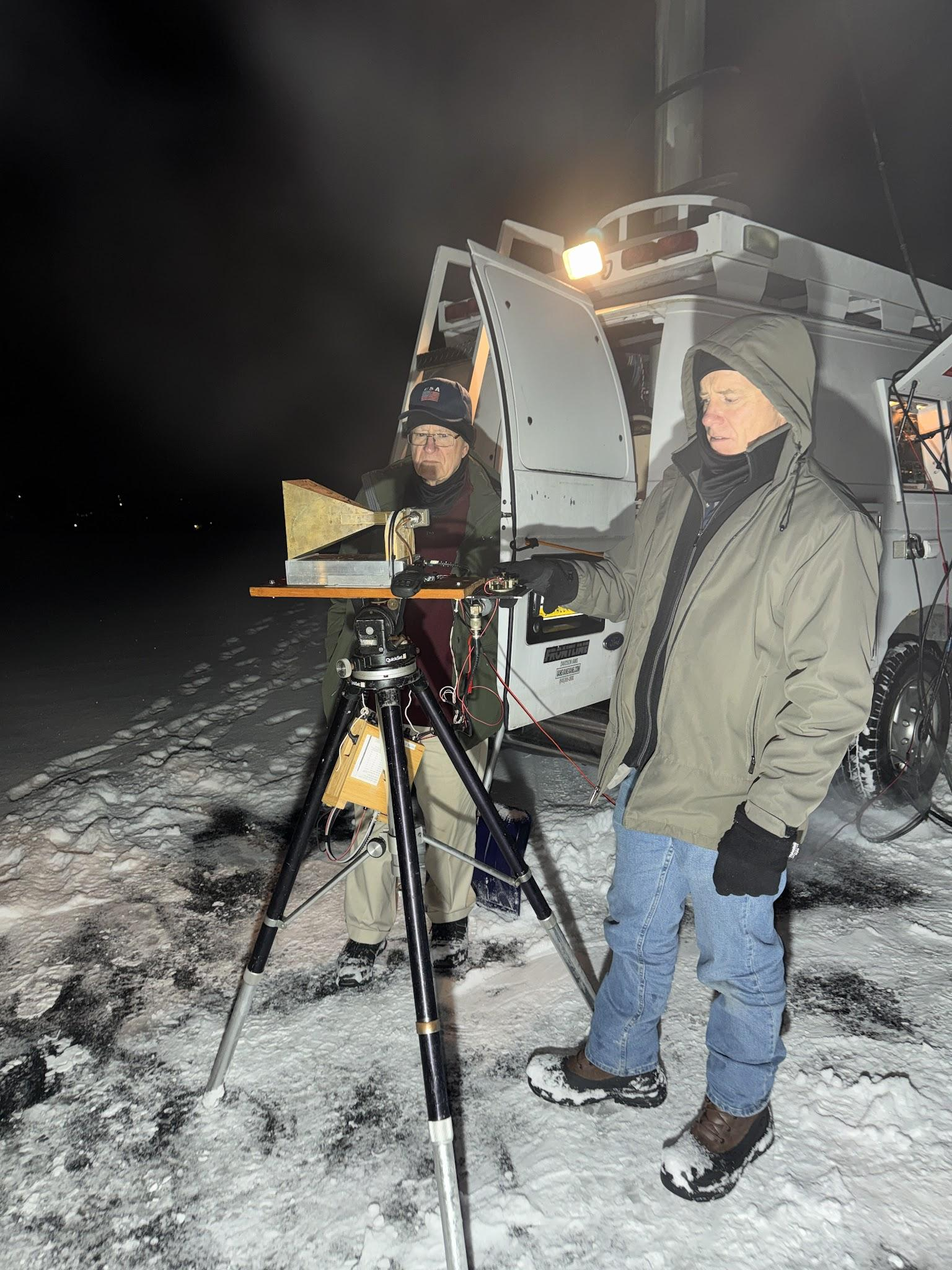
Paul and Drex operating during the evening from FN10 with Microwave

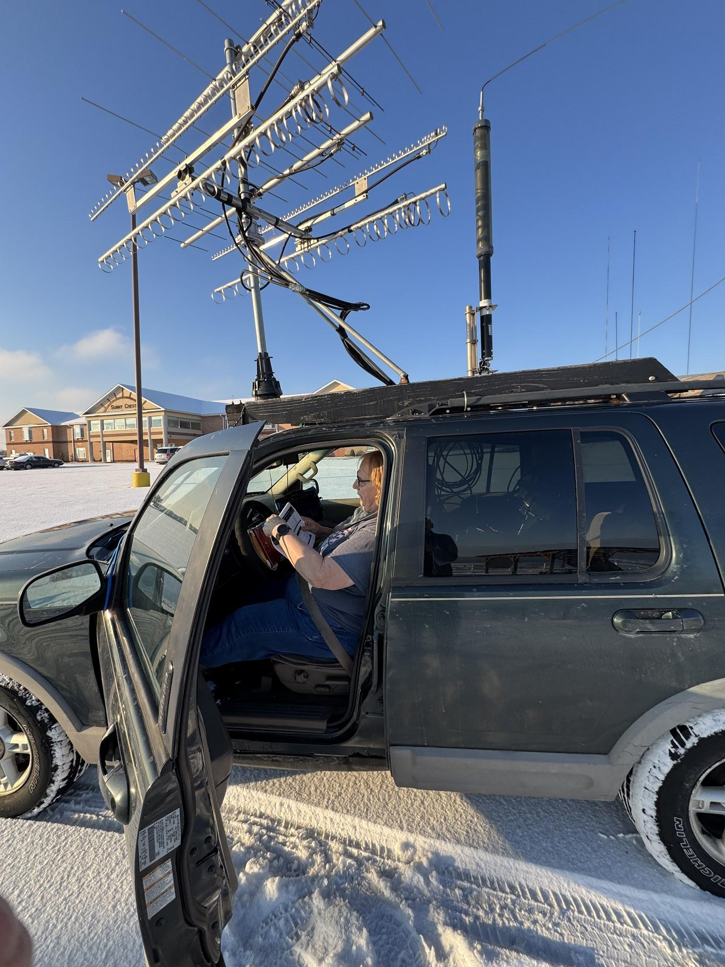
K2EZ/R Andrea working stations from FN20 during the contest start

