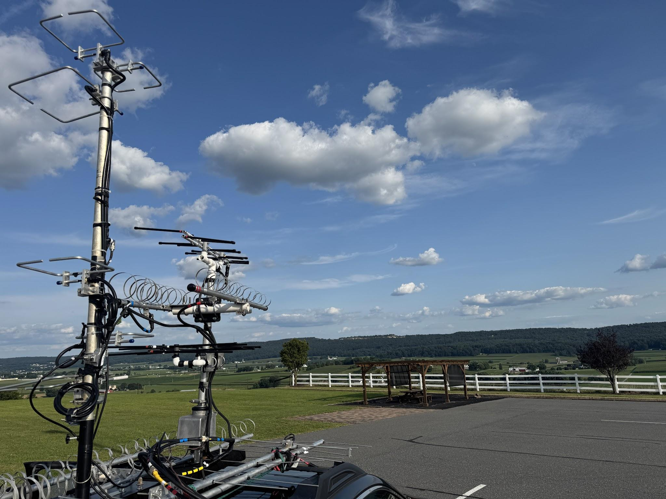
Lancaster Overlook at FN20AD located at the Sunny Crest Home with a Clear View to the East at 820ft elevation

August ARRL 222 and Up Contest AA2SD/R Rover Tests 2 Additional Bands 903 and 1296.

AA2SD/R Rover - August 2nd -3rd 2025- I started the Rove at Welsh Mountain Nature Preserve Grid FN10XC at 1000ft elevation. I have visited this spot for the Winter VHF contest although it proved to be not an ideal location due to the coverage of high trees and blocking foliage for the microwave bands. I made 12 quick contacts after setting up my larger masts and decided to move on to a new location. To add to the delays, I had no phone coverage at this site, which contributed to a lack of coordination with other operators. I worked Gary WA2OMY and Roger W3SZ easily from this location and I also worked Stephen K3WHC.

A Quick Overlook Move to FN20AD Due to Blocking Trees and Summer Foliage - I was able to adjust and move to the second location at 800 ft elevation and clear views in FN20AD in Lancaster. This location is located in Lancaster at the Sunny Crest Home at 800 ft. I noticed Chris KG6CIH Rover has visited this location before and proved to be an excellent overlook. I was able to work Gary WA2OMY on SSB with both 1296 and 903 bands with my small loopers. I also worked W3SZ Roger on 1296 and 903 and Dave K1RZ without setting up the larger antennas.

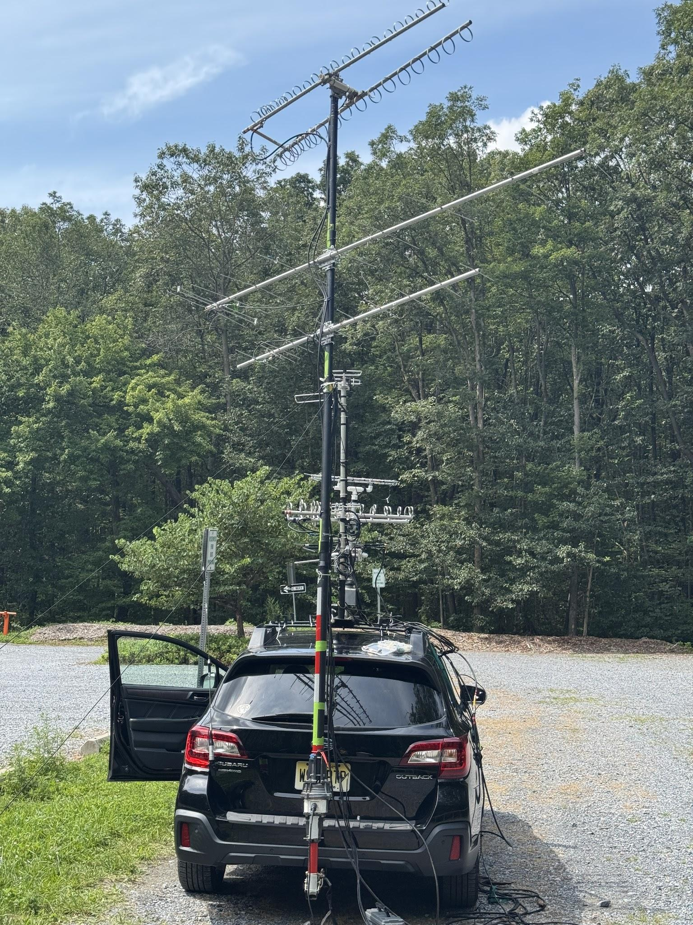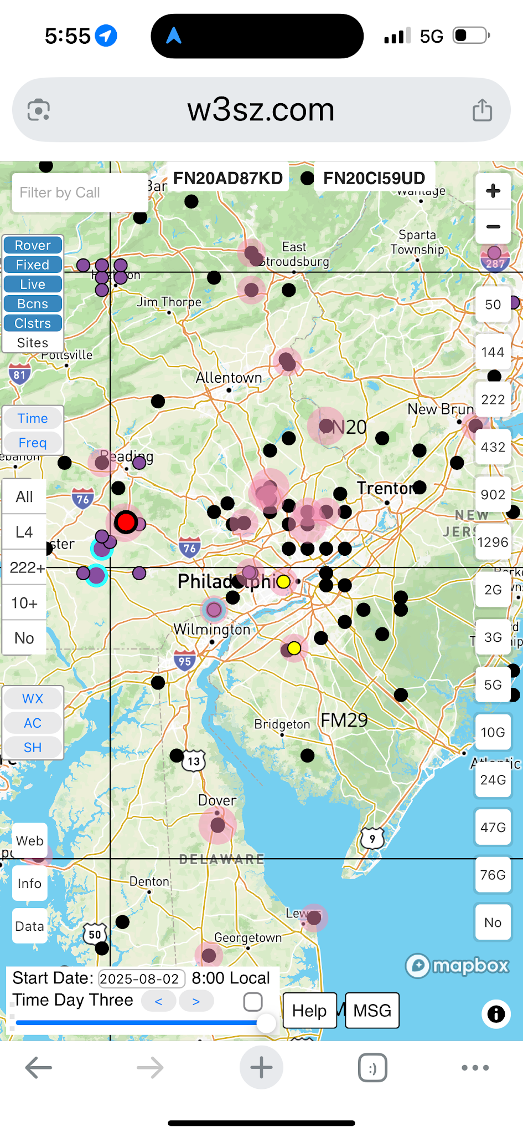
First Stop Welsh Mountain FN10XC with loopers and a 10 element Yagi

Testing 1296 and 903 as a New Rover For this Rove I deployed a pair of small loopers for 1296 and 903 on my roof rack with a small Elk 70Cm Yagi and ELK 6 Mtr 6 element 222 Mhz small beam. The smaller loopers proved to be very effective at the higher elevations and I have no set up time to operate. I also set up a larger set of Directive System loopers at the clear overlooks on a mast. I also deploy dual stack halos for the 70cm and 222MHz bands.

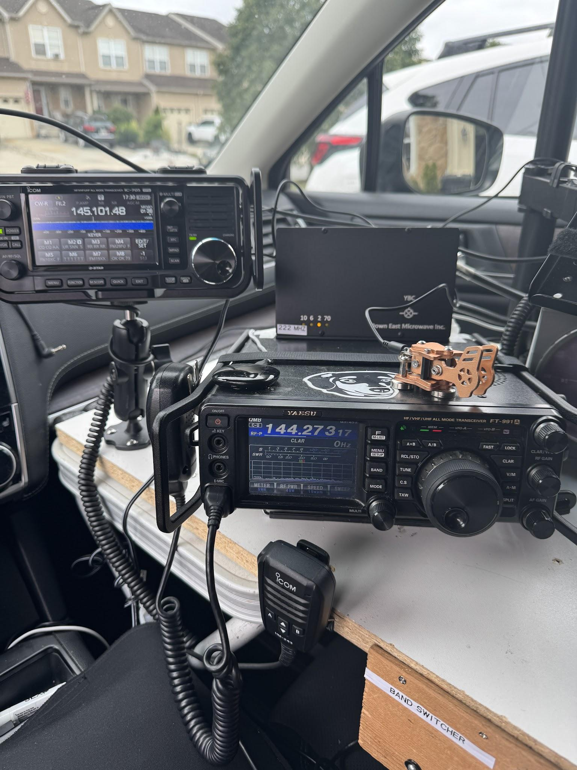
ICOM 705 mounted on a swivel mount behind the FT991A, The Down East Microwave YBC Band Switcher was added to simplify switching as a Rover.

ICOM 705 Test as an New IF Rig and YBC Band Controller from Down East Microwave - I recently acquired an ICOM 705 to use as an IF Rig for use with 903 and 1296. This new addition was very effective with the band scope and ease of menu operation compared to the FT817. On several instances I could see the station on the band scope and peak my antenna to make the QSO.

I also tested a new band controller YBC from Down East Microwave which is made specifically built for the FT991A, this switcher is linked to the 991 and will switch the IF keying for each band as you change bands in the presets or with N1MM logging software. The controller eliminates a A/B switch for use the 222 Demi Transvertor and makes for a smooth transition for ruining the bands. It splits the two common antenna ports from the transceivers HF/6M and VHF/UHF ports into 4 separate ports, HF, 6M, VHF and UHFand provides separate PTT outputs per band to control external equipment.

This YBC Band Controller mounts on the top of the FT991a and makes for a neat installation. I would recommend this for any Rover to simplify band controls with multiple transverters. You can find more information on this device at http://01895fa.netsolhost.com/PDF/YBC_pd.pdf

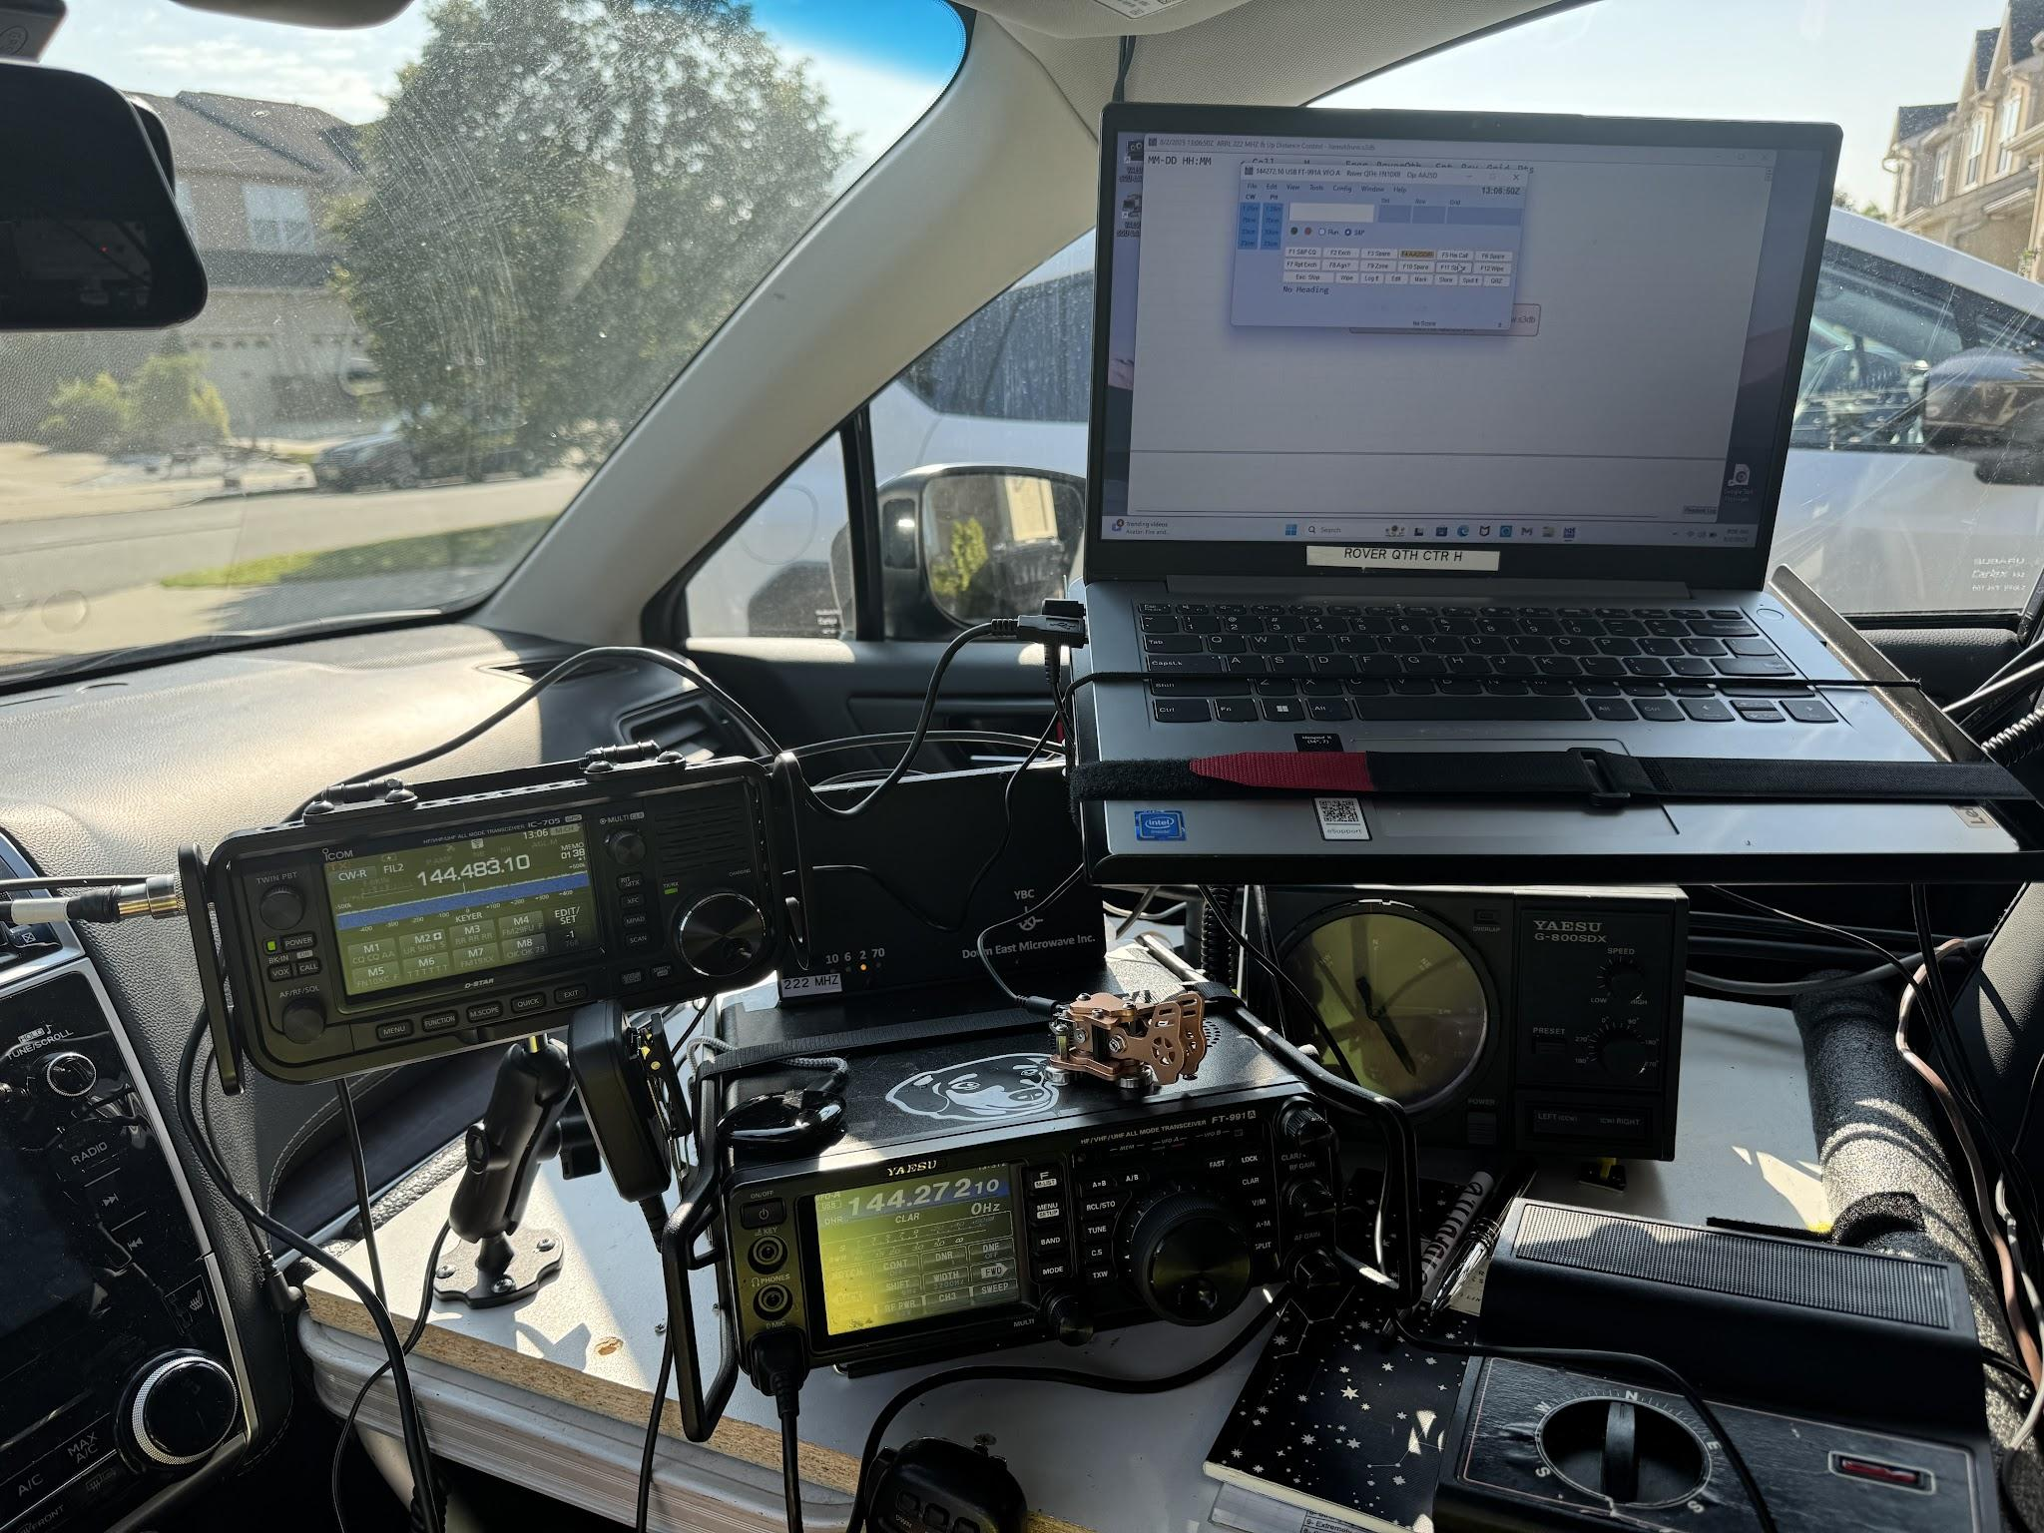This is my passenger operating shelf. All devices are secured with tie downs and zip ties .The Down East Microwave YBC Band Controller is mounted on the top back side of the FT991A.

Sunday Set up at FM29FU Ebright Azimith - One of my favorite locations is the Ebright Azimith in Delaware at 440 ft. I set up the mast Sunday Morning with the larger loopers and Yagis. I worked W2SJ on 3 bands and I was able to work Mike WB2RVX , Ray N3RG and Dave K1RZ with a clean sweep on all 4 bands.

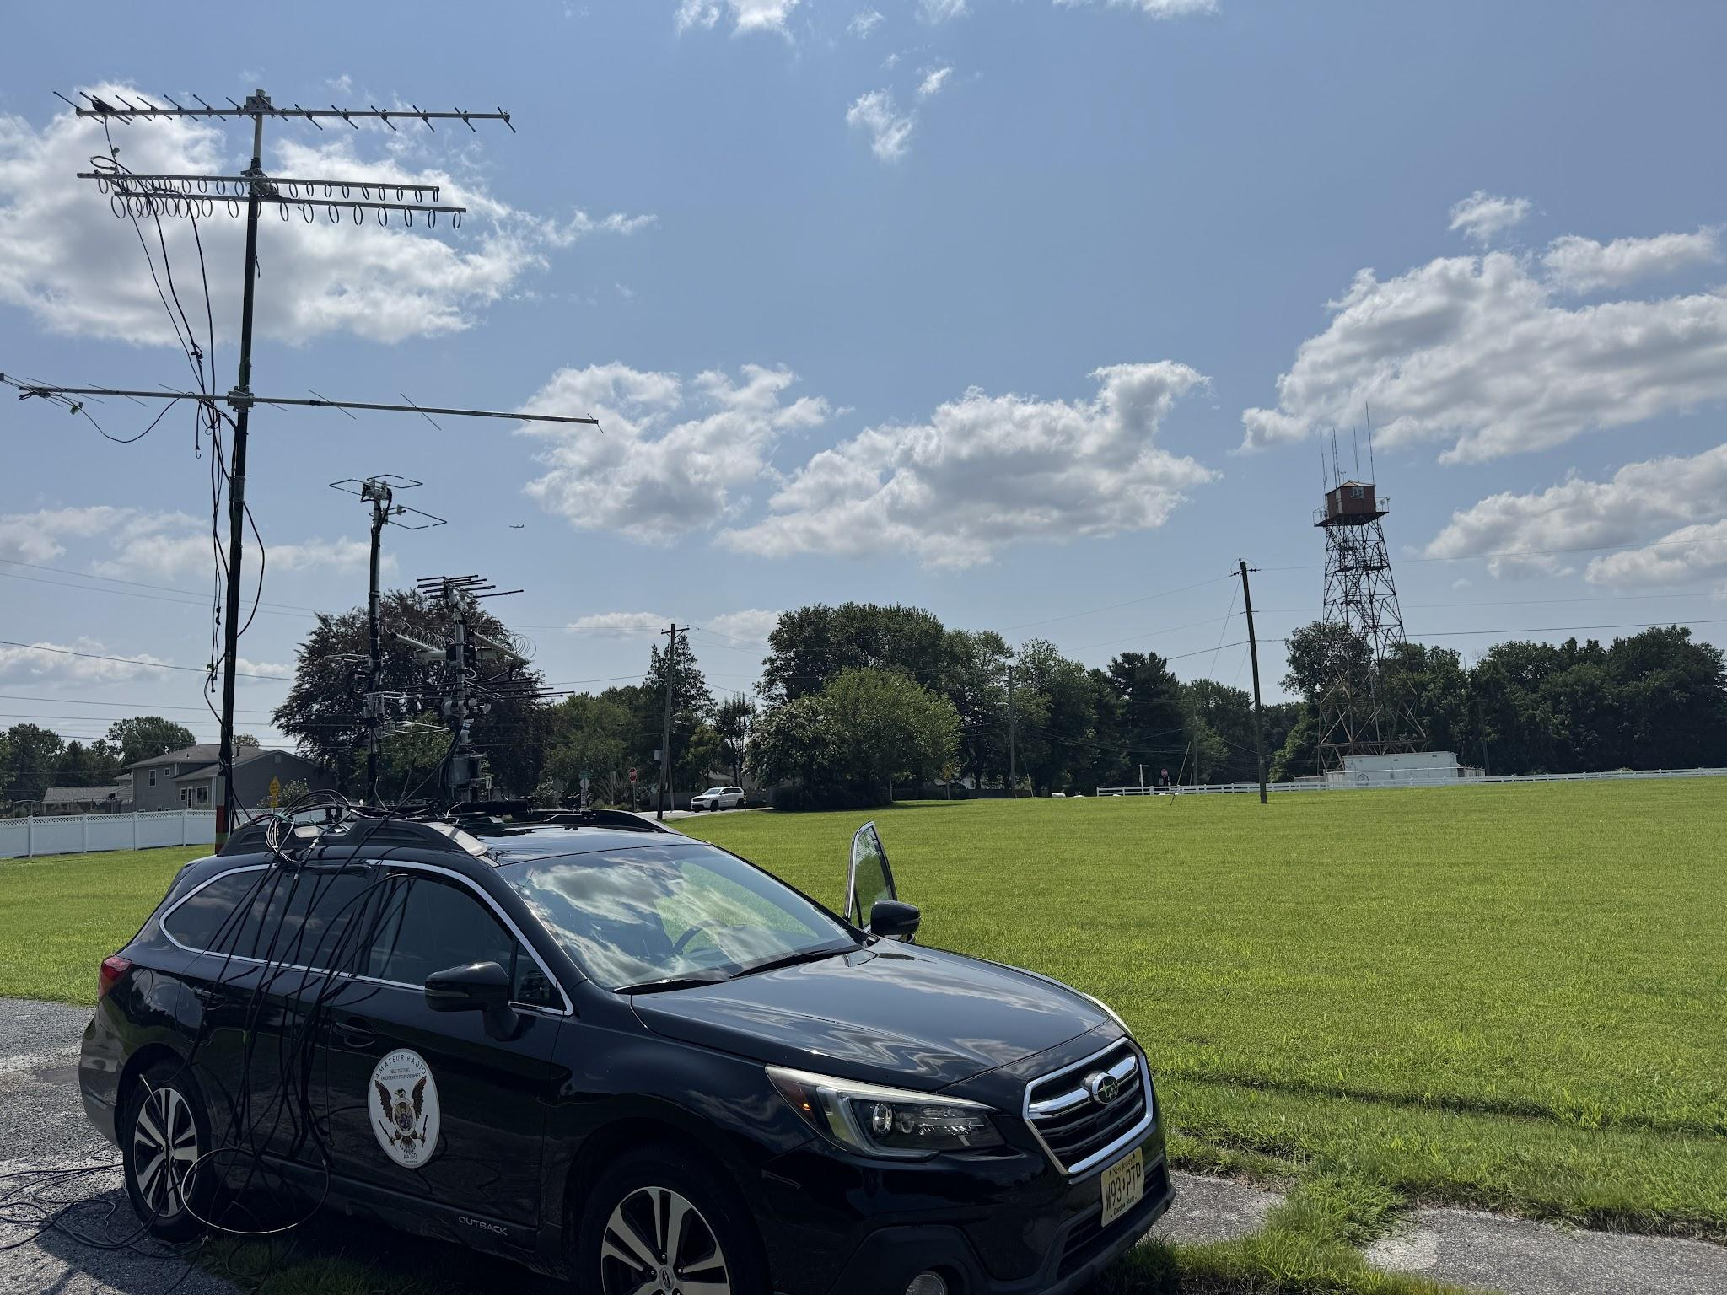
AA2SD Rover set up at Ebright Azimith FM29FU during Sunday Morning Participating in the 222 and Up Contest.

Final Rove Results. After a slow start on Saturday, I picked up the pace and worked it into the late evening. This contest is much slower than a traditional VHF contest, and I decided to stay in as long as my stamina held up and not go to FT8. Overall conditions did not appear to be very good. I decided to go back to making calls and arranging SKEDS to work on much needed 1296 and 903 operating skills. I appreciate Dave K1RZ, taking the time with Ray N3RG , Bob W2SG and Mike WB2RVX , Gary WA2OMY, and Roger W3SZ to work me on 1296 and 903.

222MHz Longest Contest as a Rover - The longest distance 222 MHz contact was Dale AF1T in New Hampshire along with Jeff K1TEO., and Roger W3SZ . Sunday at Ebright Azimith location was a good day for 1296 and 903 contacts. Thanks to Dale and Jeff and Roger for arranging SKEDS and hanging with me during the moves.

Summary of 222 and Up Activity
- 300 + Miles Logged in 2 Days (3 Grids Visited -I visited 5 unique overlook areas)
- I visited (5) overlooks - Welsh Mountain, Lancaster Hill Top, Gibbsboro NJ, and the Ebright Azimuth in Delaware, Mullica Hill Inspire Hospital Lot
- QSOs in Log : 60 (all phone with only no FT8)
- I expect the score to be lower, as the ARRL will adjust this for the longest contact per Grid Square, this is the total sum of all QSO’s as I worked the same station in multiple Grids
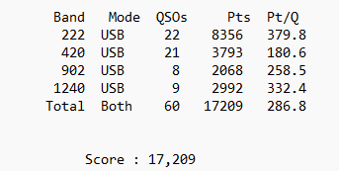

Thank You for Your Support - As a solo Rover it’s especially challenging when things get very slow, it’s easy to lose motivation to get to the next stop and call it quits. With a quick adjustment to my operating strategy and finding another ideal location I was able to pull a rabbit out of the hat. I would like to personally thank all of the Pack Rats and Friends as I am new to Roving and especially to these new bands. I am also pleased to report that the equipment acquired and passed down antennas are one the air, and making QSO’s. My main focus is in support of the club, spreading the word, learning weak signal operation and having fun operating as a new Rover.
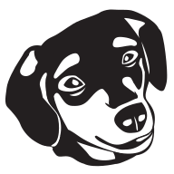
I look forward to working with you during the upcoming September VHF Contest this Fall with KE5NJ from the 100 Mile Overlook in Jim Thorpe PA.

Scott
AA2SD/R

